**ACKNOWLEDGEMENT**

I am very grateful to our principal for providing us with an environment to complete my project successfully.

I am deeply indebted to **Prof. Binita Thakkar Head of I.T Department**, VIVA College who modelled us both technically and morally for achieving greater success in life.

I express our sincere thanks **to all our lecturers**, for their constant encouragement and support throughout our course, especially for the useful suggestions given during the course of the project period. I am grateful to my internal guide **Prof. Kshitija Abhish Palav(Mane)** Lecturer, for being instrumental in the completion of our project with her complete guidance .

We would like to thank our parents for providing us with all their support and encouragement right from the project's budding stage to its current maturity .

Above all, we would like to thank the almighty for giving us the courage and energy to work day and night to make this project a grand success.

**DECLARATION**

I hereby- declare that the project entitled, **“Electronic-Gift Shop”** done at **Viva College Virar West**, has not been in any case duplicated to submit to any other university for the award of any degree. To the best of my knowledge other than me, no one has submitted to any other university.

The project is done in partial fulfilment of the requirements for the award of the degree of **BACHELOR OF SCIENCE (INFORMATION TECHNOLOGY)** to be submitted as a final semester project as part of our curriculum.

**(Shitole Deep Vijay)**

**TABLE OF CONTENT**

|  |  |  |
| --- | --- | --- |
| **Chapter** | **Chapter Name** | **Page No** |
| **1** | **Introduction** | 5 |
|  | 1.1 Background | 6 |
|  | 1.2 Objective | 7 |
|  | 1.3 Purpose, Scope and Applicability | 8 |
|  | 1.3.1 Purpose | 8 |
|  | 1.3.2 Scope | 9 |
|  | 1.3.3 Applicability | 10 |
| **2** | **Survey of Technology** | 11 |
| **3** | **Requirement and Analysis** | 12 |
|  | 3.1 Problem Statement | 12 |
|  | 3.2 Requirement Specification | 13 |
|  | 3.3 Planning and Scheduling |  |
|  | 3.3.1 Gantt Chart | 14 |
|  | 3.3.2 Pert Chart | 15 |
|  | 3.4 Software and Hardware Requirement | 16 |
|  | 3.5 Preliminary Product Description | 17 |
|  | 3.6 Conceptual model |  |
|  | 3.6.1 Event Table | 18 |
|  | 3.6.2 ER Diagram | 19 |
|  | 3.6.3 Use Case Diagram | 20 |
|  | 3.6.4 Sequence Diagram | 21 |
|  | 3.6.5 Class Diagram | 22 |
|  | 3.6.6 State Diagram | 23 |
| 4 | **System Design** | 24 |
|  | 4.1 Basic Module | 25 |
|  | 4.2 Data Design | 26 |
|  | 4.2.1 Schema Design with Data Integrity and Constraints | 27-28 |
|  | 4.2.2 Database Relationship Design | 29 |
|  | 4.4 Security Issues | 30 |
| **5** | **Implementation and Testing** |  |
|  | 5.1 Implementation Approaches | 31 |
|  | 5.2 Coding Details and Efficiency | 32-66 |
|  | 5.3 Testing | 67 |
|  | 5.3.1 Unit Testing | 67 |
|  | 5.3.2 Integration Testing… | 68 |
|  | 5.3.3 Beta Testing | 69 |
|  | 5.3.4 Test Cases | 70-72 |
| **6** | **Result and Discussion** |  |
|  | 6.1 Test Reports | 73-74 |
|  | 6.2 User Documentation | 75 |

|  |  |  |
| --- | --- | --- |
| **7** | **Conclusion** |  |
|  | 7.1 Conclusion | 76 |
|  | 7.2 Significance of the system | 77-78 |
|  | 7.3 Limitations of the system | 79 |
|  | 7.4 Future Scope of the project | 80-81 |
|  | **References** | 82 |

**1.INTRODUCTION**

The website would provide a platform for customers to browse and purchase products, with a user-friendly interface for a convenient and enjoyable shopping experience.

A ‘Electronic-Gift Shop’ portal will allow a business to advertise their products, manage their inventory and sell their products on the internet.

My project is an web application for ordering a Gift , titled "**Electronic-Gift Shop**", built using MySql as the main language for backend and HTML, CSS and PHP as the frontend.

Electronic-Gift Shop System is a web based application which allows the administrator to handle all the activities online quickly and safely.

Using interactive GUI anyone can quickly learn to use the complete system. This system will give power and flexibility to administrator to mange the entire system from single online portal.

Electronic-Gift Shop is an established concept which is used to manage Electronic-Gift Shop lifecycle through various technologies and process oriented tools.

This study identifies how web application can be utilize to provide Gift service to the customer and to understand the potential of web application in the environment

Electronic-Gift Shop focus on providing Gift to the customers. Online Gift ordering is the process of ordering Gift through a web page from a local Gift or Gift cooperative. Just as consumer goods are ordered online, many of these allow customers to have accounts with them to make them easy

**1.1.BACKGROUND**

Ordering Gift is a fun experience. Everybody likes to order Gift from Shop. However, during covid, a lot of people had to order Gift compulsively from these Shop. A typical household in India believes that ordering Gift from Shop can be unhealthy and bad for nutrition.

Right during this time of adversity, a lot of pamphlets of Gift services started flowing around and big ads started appearing in newspapers. The Gift service industry started marketing to the core. Every Gift service owner wanted a big share of the user. But the user could get baffled. Choosing from multiple pamphlets, tv ads and WhatsApp shares do not create a feasible experience for the user. This called out on the necessity to have all the Gift services in one place.

The Gift prepared at home is cheaper than the Shop Gift and keeps doctors away makes us healthy.

The main goal is providing high quality Gift at low cost.

**1.2OBJECTIVES**

The aim of doing this project is to have practical knowledge of Gift services team and their actual performance in the supply and management of Gift delivery service.

The proposed system is developed to manage ordering activities in fast Gift Gift. It helps to record customer submitted orders.

The system should cover the following functions in order to support the Gift's business process for achieving the objectives:

To allow the customer to make order, view order and make changes before submitting their order and allow them make payment through prepayment card or credit card or debit card.

To provide interface that allows promotion and menu.

To prevent interface that shows customers' orders detail to front-end and Delivery Boy for delivering customers' orders

Tools that generate reports that can be used for decision making.

A tool that allows the management to modify the Gift information such as price , add a new menu and many others as well as tools for managing user, system menu and promotion records

**1.3PURPOSE,SCOPE AND APPLICABILITY**

**PURPOSE**

The purpose of this project is to demonstrate my ability to develop a fully functional ecommerce website for fashion and lifestyle using Python Django, HTML, CSS, and PHP.

By developing this project, I aim to showcase my skills and knowledge in web development, as well as my ability to apply best practices in website design and development to create an efficient and user-friendly online platform for businesses and customers.

There is reason of choosing this topic cause ,noticed that in covid 19 pandemic there is lot of people they are suffering from Gift problem, they didn’t get Gift on time and quality Gift in this situation the online Gift ordering systems comes n demand.

This Electronic-Gift Shop is used to give a home made high quality Gift in low cost which will be the benefit for customer.

**SCOPE**

The scope of our project includes the development of a website with a user-friendly interface, customizable storefronts, and a range of tools for inventory and order management.

Our website also features a secure and reliable payment processing system, personalized recommendations, and a responsive design that adapts to various devices and browsers.

Through this project, I Will gained valuable experience in developing a functional website using MySql, HTML, CSS, and PHP. I will also learned about the different aspects of web application, such as payment gateway integration, security considerations, and user experience design.

The skills and knowledge gained from this project can be applied to various real-world web based projects, making me a more competitive candidate in the job market.

By completing this project, I have demonstrated my ability to work with these tools and my understanding of web based projects , which will undoubtedly help me in my developer career

**APPLICABILITY**

This project is applicable to the Electronic-Gift Shop of all types, from small area to the city.

My website can be customized to suit the specific needs and preferences of individual, allowing them to showcase their unique Dishes online.

Presentation –

The design of any ecommerce website is its lifeblood. It not only has to be easy to read and use, but it also needs to stand out.

Service that excels –

Many of the best online retailers use promotions and customer service together. By intertwining them, it binds customers to the brand and creates long lasting brand loyalty.

Automation –

The entire process can be done without conversation with another person, Just a few clicks and purchases are made.

Online Gift ordering offers customers to more easy way of ordering their Gift and looking for something great that they can eat while sitting at home

Personalization –

Online Gift tend to regard personalized offers highly. Many customers will order around for the best deal.

Customized results –

Filtering systems, customer also tend to demand to quickly find the product they want. An easy and effective filter system also contributes to an online ordering interface.

Filtering –

Allows customers to easily access other areas of an Electronic-Gift Shop. This allows customers to find similar products to the ones they searched for, whilst enjoying their browsing experience.

**2.SURVEY OF TECHNOLOGY**

**Front-end :**

Html , Css , Php

In the frontend of the E-commerce website, I have used HTML, CSS, and JavaScript. These technologies provide the user interface and user experience of the website. HTML provides the structure of the website, CSS provides the styling, and JavaScript provides the interactivity and dynamic functionality. Together, they create a visually appealing and responsive website that enhances the user's shopping experience.

Php is open source software. Php is free to download.

**Back-end :**

MySql

MySQL is an **open source relational database management system**. For WordPress sites, that means it helps you store all your blog posts, users, plugin information, etc. It stores that information in separate “tables” and connects it with “keys”, which is why it’s relational.

Mysql is a database server

Mysql is ideal for both small and large application Mysql compiles on various platform

Mysql is free to download and use

**3.REQUIRMENT AND ANALYSISI**

**3.1 PROBLEM DEFINATION**

* The existing system is manual system. Needs to be converted into automated system.

* Risk of mismanagement of data.

* Less Security.

* No proper coordination between different Applications and Users.

* Fewer Users - Friendly.

* Accuracy not guaranteed.

* Not in reach of distant users.

**3.2 REQUIRMENT SPECIFICATION**

**Functional Requirements:**

Create account/Login

Access personal details such as Orders and Addresses

Logical Database

Search products

Browse products

Add/Remove products from Bag

Add/Remove products from Wishlist

Place order

Checkout/Pay

**Non-Functional Requirements:**

Usability

Performance

Reliability

Scalability

Accessibility

Maintainability

Responsive User Interface Design

**3.3 PLANNING AND SCHEDULING**

**GANTT CHART**

**PERT CHART**

**3.4 SOFTWARE HARDWARE REQUIRMENT**

**Software Requirment:**

Operating system: Windows

Database : MySql

Front end : Html,css,Php

IDE : visual studio code

**Hardware Requirements:**

Device: Laptop or PC

Processor: Intel Core i5 or better

RAM: 8 GB or more

Hard drive space: 100 GB or more

System type: *64 bit

Internet connectivity

**3.5.PRELIMINARY PRODUCT AND DESCRIPTION**

Software design sits at the technical kernel of the software engineering process and is applied regardless of the development paradigm and area of application. Design is the first step in the development phase for any engineered product or system. The designer’s goal is to produce a model or representation of an entity that will later be built. Beginning, once system requirement have been specified and analyzed, system design is the first of the three technical activities -design, code and test that is required to build and verify software.

The importance can be stated with a single word “Quality”. Design is the place where quality is fostered in software development. Design provides us with representations of software that can assess for quality. Design is the only way that we can accurately translate a customer’s view into a finished software product or system. Software design serves as a foundation for all the software engineering steps that follow. Without a strong design we risk building an unstable system – one that will be difficult to test, one whose quality cannot be assessed until the last stage.

During design, progressive refinement of data structure, program structure, and procedural details are developed reviewed and documented. System design can be viewed from either technical or project management perspective. From the technical point of view, design is comprised of four activities – architectural design, data structure design, interface design and procedural.

**3.6.CONCEPTUAL MODEL:**

**3.6.1 EVENT TABLE**

|  |  |  |  |  |
| --- | --- | --- | --- | --- |
| Event | Trigger | Use-case | Source | Response |
| Customer/Admin Login | Login | Manage account | Customer/ Admin | Successful/ failed |
| View/handle product | Request for  View product details | Organize/find product | Customer/ Admin | Product added/saved |
| View/update profile | Request for  Viewing or  Updating profile | Manage profile | Customer/ Admin | Profile added/updated |
| Change/browse product | Change the Product details | Manage product | Customer/ Admin | Product displayed |
| Check BMI  Add/check Product details | Calculate  BMI | Find BMI index | Customer | Value generated |
| Add or check Product details | Manage product details | Admin | Product details added/ displayed |

**3.6.2.ENTITY RELATIONSHIP DIAGRAM**

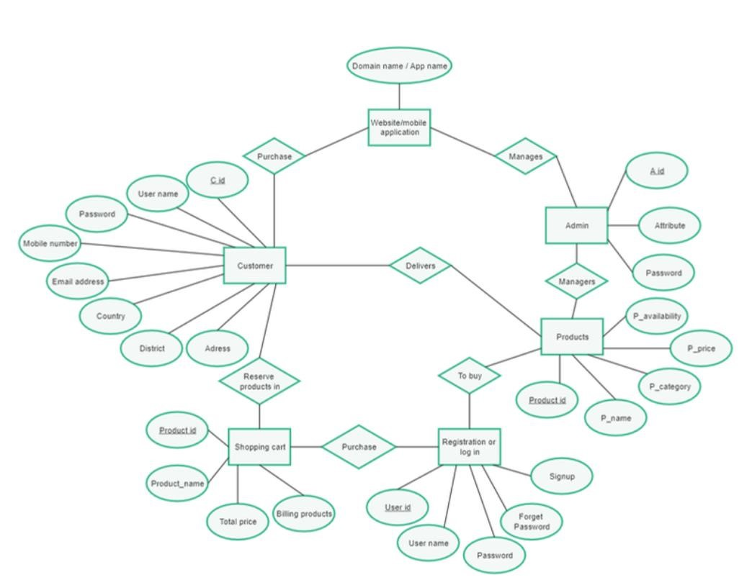

**3.6.3 USE CASE DIAGRAM**

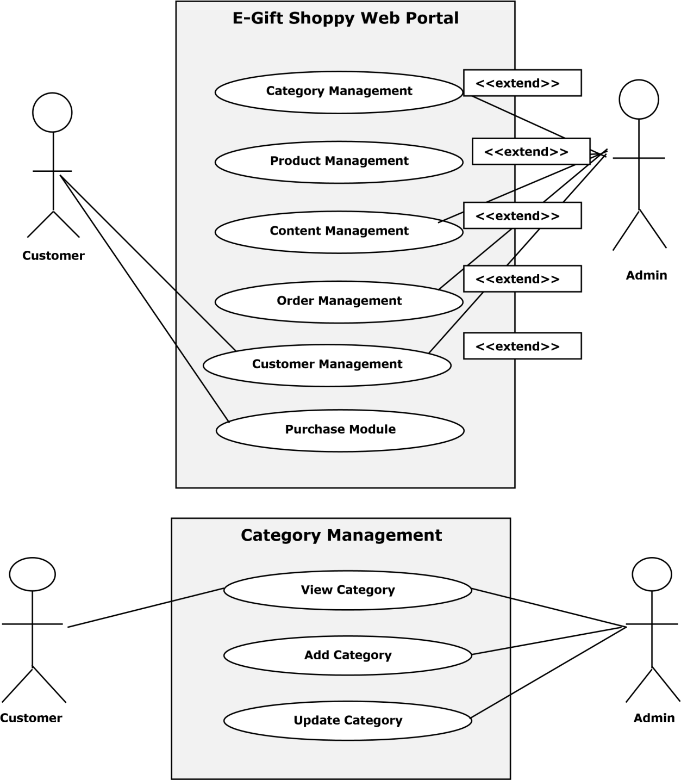

**3.6.4.SEQUENCE DIAGRAM**

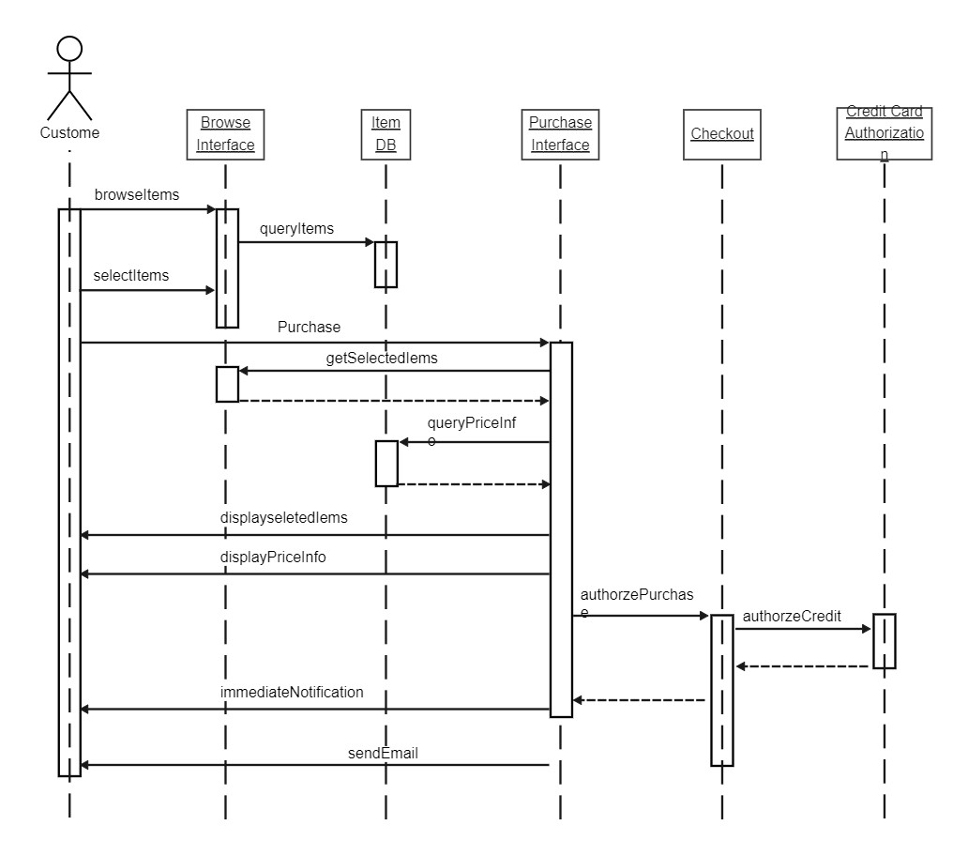

**3.6.5 CLASS DIAGRAM**

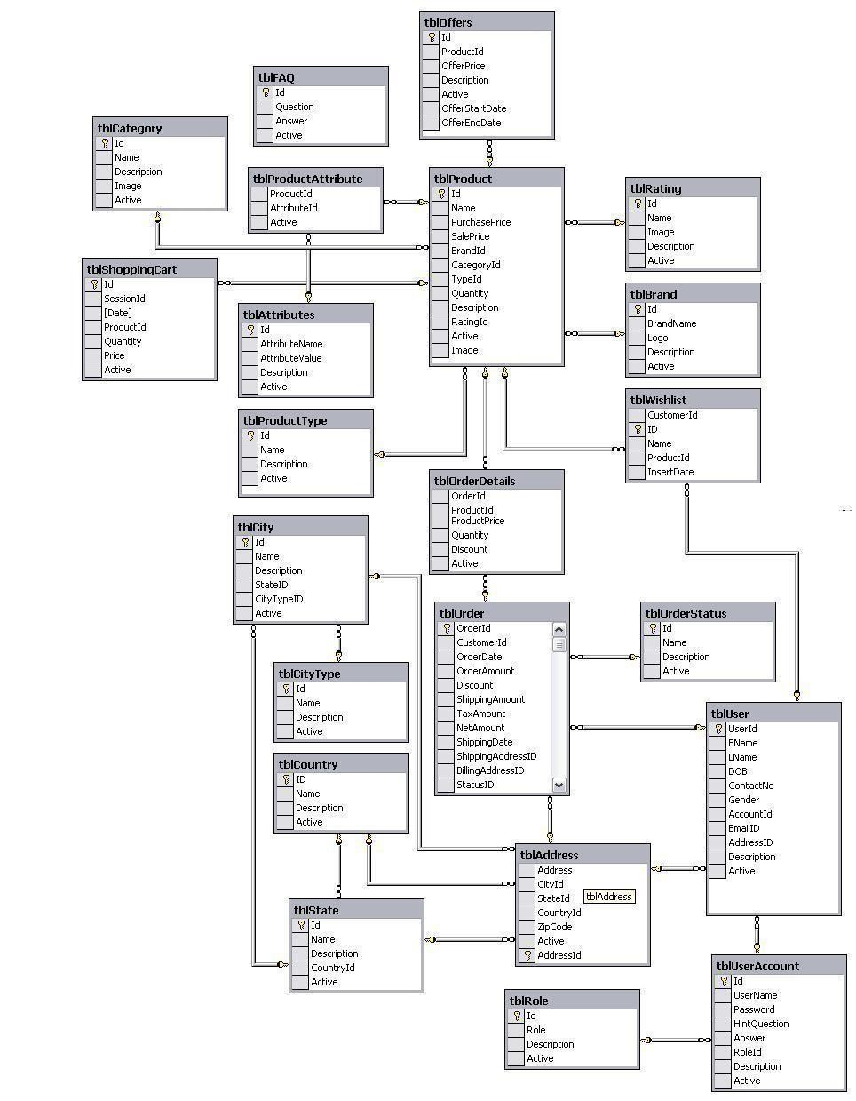

**3.6.6 STATE DIAGRAM**

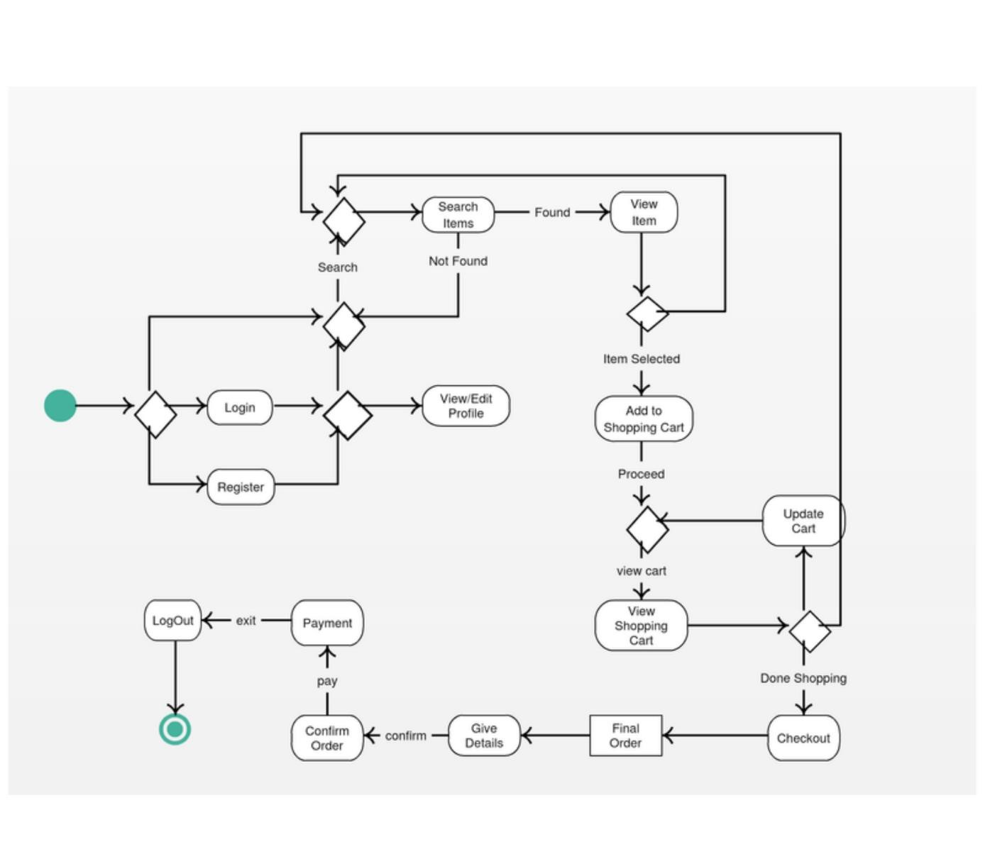

**4.System Design**

**Basic Module:**

Admin

* Manage job seeker and employer profile.
* Manage payments of employer.
* Add new services, related to employer and job seeker.
* Provide rules and authentication to users.

1. Customer
2. Product
3. Website Administrator
4. Operator
5. Order
6. **Customer:** The target user of the system. A Customer is responsible for registering them to the site, browsing site, placing orders and making payments.
7. **Product:** Product is the entity, a customer looking for. A Product will be sold to the customer.
8. **Website Administrator:** An entity responsible for managing users, roles and roles privileges.
9. **Operator:** Operator is a person (entity) responsible for managing products and orders.
10. **Order**: Order is an entity which describes the business transaction. 11)

**4.2DATA DESIGN**

**4.2.1.SCHEMA DESIGN WITH DATA INTIGRITY AND CONSTRAINTS**

**Primary Key Constraint**-

Primary Key constraint uniquely identifies each record in a database. A primary key must contain unique value and it must not contain null value. Usually primary key is used to index the data inside the table.

**Not Null Constraint-**

Not null constraint make sure that a column is not left null. It forces the person to enter some value else it will show an error.

**Unique Constraint-**

Unique constraint the name itself suggest that a column will have a unique values. This constraints makes sure that the column don’t have any duplicate value. It can applied to column level or table level.

**Auto Increment-**

The constraint applied to which ever column will see that it increments itself whenever a new record is inserted, so that the duplication is not generated.

**DATABASE TABLES**

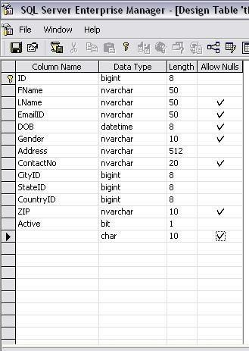

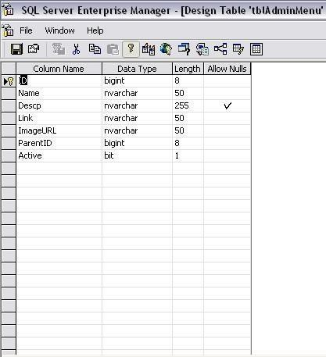

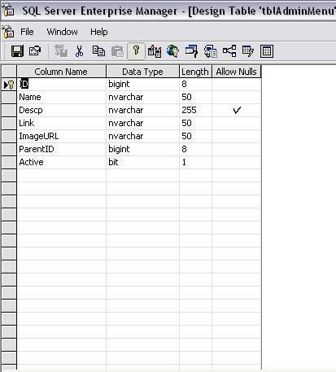

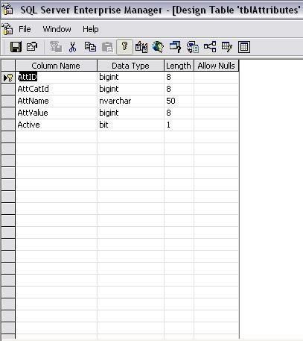

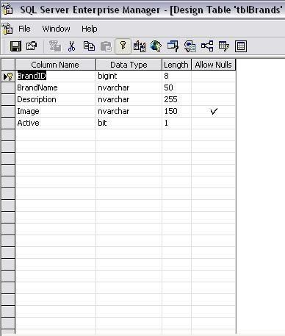

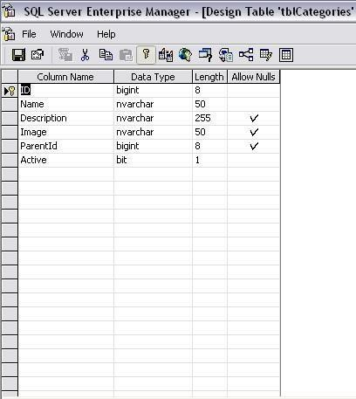

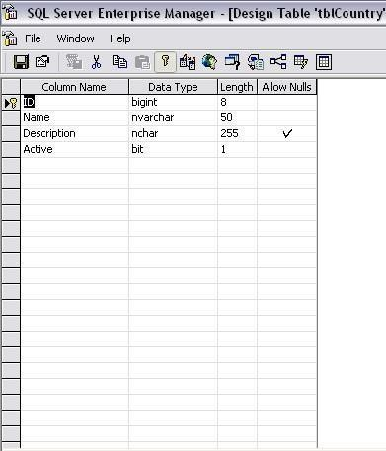

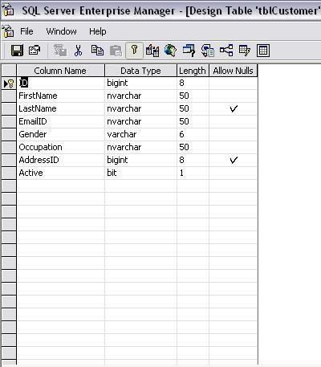

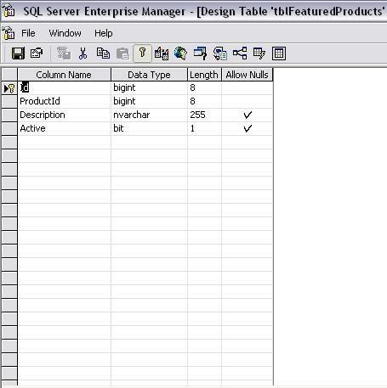

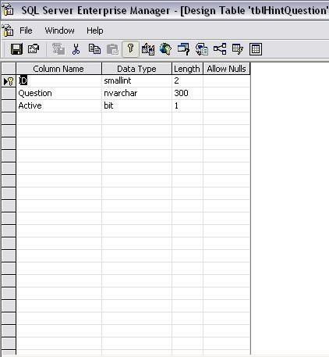

**4.4 SECURITY ISSUE**

**Password Security:**

Passwords are the first line of defense against unauthorized access to customer accounts. Poor password management practices can make customer accounts vulnerable to hacking attempts. To mitigate this risk, it's important to enforce this setting up password on an account would need OTP verification via email.

**Unencrypted data:**

Some websites don’t encrypt data. If they don’t have an up-to-date [SSL certificate](https://www.kaspersky.com/resource-center/definitions/what-is-a-ssl-certificate), they are more vulnerable to attacks. Websites whose URL starts with HTTP rather than HTTPS are not secure – which is a risk for shoppers sharing credit card details and other sensitive information with that site.

**Fake reviews:**

Many online shoppers read reviews before they buy. But be aware that not all online reviews are genuine. If a particular retailer has a pattern of reviews that seem too good to be true or lack detail, try to check the source and listen to your instincts.

**Wi-Fi threats, in public and at home:**

[Public Wi-Fi carries risks](https://www.kaspersky.com/resource-center/preemptive-safety/public-wifi-risks) because the security on these networks – in coffee shops, shopping malls, airports, hotels, Shop, and so on – is often lax or non-existent. The lack of security means that cybercriminals and identity thieves can monitor what you are doing online and steal your passwords and personal information

**Payment Security:**

Ecommerce sites process a large volume of sensitive customer data, including credit card information. Any breach of this information can lead to significant financial loss and damage to the reputation of the ecommerce site. To protect against this risk, it's important to ensure that the site is using secure payment gateways that meet the latest security standard and provide a secure payment gateway.

**5.IMPLEMENTATION AND TESTING**

**5.1.IMPLEMENTATION APPROACHES**

Before beginning with the project implementation, studying the various technologies used was necessary.

The technologies used in making the web PHP, MySQL Server, Visual Studio Code.

The project contains modules which depended on each other the next module is depended on its previous module so that we selected bottom-up approach to implement project to work with Visual Studio, PHP and MySQL server, we understood the basic concept of it.

After that we search some application and videos on internet for reference.

We have started with the implementation process.

**5.2.CODING DETAILS AND CODING EFFICIENCY**

**Login.php:**

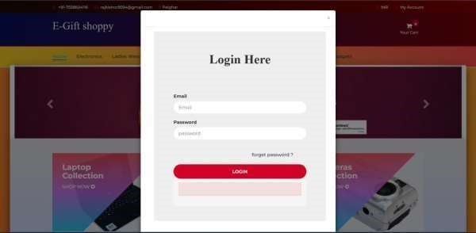

**Header.php:**

<?php include "db.php"; session_start();

#Login script is begin here

#If user given credential matches successfully with the data available in database then we will echo string login_success

#login_success string will go back to called Anonymous funtion

$("#login").click()

if(isset($_POST["email"]) && isset($_POST["password"])){

$email = mysqli_real_escape_string($con,$_POST["email"]);

$password = $_POST["password"];

$sql = "SELECT * FROM user_info WHERE email = '$email' AND password =

'$password'";

$run_query = mysqli_query($con,$sql); $count = mysqli_num_rows($run_query);

$row = mysqli_fetch_array($run_query);

$_SESSION["uid"] = $row["user_id"];

$_SESSION["name"] = $row["first_name"];

$ip_add = getenv("REMOTE_ADDR");

//we have created a cookie in login_form.php page so if that cookie is available means user is not login

//if user record is available in database then $count will be equal to 1 if($count == 1){

if (isset($_COOKIE["product_list"])) {

$p_list = stripcslashes($_COOKIE["product_list"]);

//here we are decoding stored json product list cookie to normal array

$product_list = json_decode($p_list,true); for ($i=0; $i < count($product_list); $i++) {

//After getting user id from database here we are checking

user cart item if there is already product is listed or not

$verify_cart = "SELECT id FROM cart WHERE user_id =

$_SESSION[uid] AND p_id = ".$product_list[$i];

$result = mysqli_query($con,$verify_cart); if(mysqli_num_rows($result) < 1){

//if user is adding first time product into cart we

will update user_id into database table with valid id

$update_cart = "UPDATE cart SET user_id =

'$_SESSION[uid]' WHERE ip_add = '$ip_add' AND user_id = -1"; mysqli_query($con,$update_cart);

}else

//if already that product is available into database

table we will delete that record

$delete_existing_product = "DELETE FROM cart WHERE

user_id = -1 AND ip_add = '$ip_add' AND p_id = ".$product_list[$i]; mysqli_query($con,$delete_existing_product); }

}

//here we are destroying user cookie setcookie("product_list","",strtotime("-1 day"),"/");

//if user is logging from after cart page we will send cart_login echo "cart_login";

exit();

}

//if user is login from page we will send login_success echo "login_success";

$BackToMyPage = $_SERVER['HTTP_REFERER']; if(!isset($BackToMyPage)) { header('Location: '.$BackToMyPage); echo"<script type='text/javascript'>

</script>";

} else {

echo "<script> location.href='index.php'; </script>" ;// default page

}

exit;

}else{

$email = mysqli_real_escape_string($con,$_POST["email"]);

$password =md5($_POST["password"]) ;

$sql = "SELECT * FROM admin_info WHERE admin_email = '$email'

AND admin_password = '$password'";

$run_query = mysqli_query($con,$sql);

$count = mysqli_num_rows($run_query);

//if user record is available in database then $count will be equal to 1 if($count == 1){

$row = mysqli_fetch_array($run_query);

$_SESSION["uid"] = $row["admin_id"];

$_SESSION["name"] = $row["admin_name"];

$ip_add = getenv("REMOTE_ADDR");

05

//we have created a cookie in login_form.php page so if that

cookie is available means user is not login

//if user is login from page we will send login_success echo "login_success";

echo "<script> location.href='admin/add_products.php';

</script>"; exit;

}else{ echo "<span style='color:red;'>Please register before

login..!</span>";

exit();

}

}

}

**Footer.php:**

<footer class="footer">

<div class="container">

<div class="bottom-footer">

<div class="row">

<div class="col-xs-12 col-sm-3 payment-options color-gray">

<h5>Payment Options</h5>

<ul>

<li>

<a href="#"> <img src="images/paypal.png" alt="Paypal"> </a>

</li>

<li>

<a href="#"> <img src="images/mastercard.png" alt="Mastercard"> </a>

</li>

<li>

<a href="#"> <img src="images/maestro.png" alt="Maestro"> </a>

</li>

<li>

<a href="#"> <img src="images/stripe.png" alt="Stripe"> </a>

</li>

<li>

<a href="#"> <img src="images/bitcoin.png" alt="Bitcoin"> </a></li>

</ul></div>

<div class="col-xs-12 col-sm-4 address color-gray">

<h5>Address</h5>

<p>1086 Stockert Hollow Road, Seattle</p>

<h5>Phone: 75696969855</a></h5> </div>

<div class="col-xs-12 col-sm-5 additional-info color-gray">

<h5>Addition informations</h5>

<p>Join thousands of other Shop who benefit from having partnered with us.</p>

</div></div></div></div></footer>

**UserInterface:**

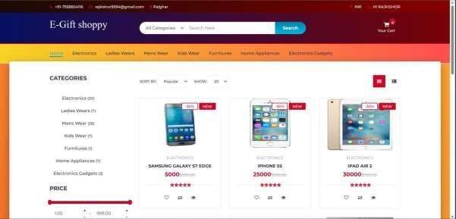

<?php session_start(); include "db.php";

if (isset($_POST["f_name"])) {

$f_name = $_POST["f_name"];

$l_name = $_POST["l_name"];

$email = $_POST['email'];

$password = $_POST['password'];

$repassword = $_POST['repassword'];

$mobile = $_POST['mobile'];

$address1 = $_POST['address1'];

$address2 = $_POST['address2'];

$name = "/^[a-zA-Z ]+$/";

$emailValidation = "/^[_a-z0-9-]+(\.[_a-z0-9-]+)*@[a-z0-9]+(\.[a- z]{2,4})$/";

$number = "/^[0-9]+$/";

if(empty($f_name) || empty($l_name) || empty($email) || empty($password) || empty($repassword) || empty($mobile) || empty($address1) || empty($address2)){

echo "

<div class='alert alert-warning'>

<a href='#' class='close' data-dismiss='alert' aria-

label='close'>&times;</a><b>PLease Fill all fields..!</b> </div> "; exit();

} else { if(!preg_match($name,$f_name)){ echo "

<div class='alert alert-warning'>

<a href='#' class='close' data-dismiss='alert' aria-

label='close'>&times;</a>

<b>this $f_name is not valid..!</b>

</div> "; exit(); } if(!preg_match($name,$l_name)){ echo "

<div class='alert alert-warning'>

<a href='#' class='close' data-dismiss='alert' aria-

label='close'>&times;</a>

<b>this $l_name is not valid..!</b>

</div> "; exit(); } if(!preg_match($emailValidation,$email)){ echo "

<div class='alert alert-warning'>

<a href='#' class='close' data-dismiss='alert' aria-

label='close'>&times;</a>

<b>this $email is not valid..!</b>

</div> "; exit(); } if(strlen($password) < 9 ){ echo "

<div class='alert alert-warning'>

<a href='#' class='close' data-dismiss='alert' aria-

label='close'>&times;</a>

<b>Password is weak</b>

</div> "; exit(); }

if(strlen($repassword) < 9 ){ echo "

<div class='alert alert-warning'>

<a href='#' class='close' data-dismiss='alert' aria-

label='close'>&times;</a>

<b>Password is weak</b>

</div> "; exit(); } if($password != $repassword){ echo "

<div class='alert alert-warning'>

<a href='#' class='close' data-dismiss='alert' aria-

label='close'>&times;</a>

<b>password is not same</b>

</div>

"; } if(!preg_match($number,$mobile)){ echo "

<div class='alert alert-warning'>

<a href='#' class='close' data-dismiss='alert' aria-

label='close'>&times;</a>

<b>Mobile number $mobile is not valid</b> </div> "; exit(); } if(!(strlen($mobile) == 10)){ echo "

<div class='alert alert-warning'>

<a href='#' class='close' data-dismiss='alert' aria-

label='close'>&times;</a>

<b>Mobile number must be 10 digit</b>

</div> "; exit();

}

//existing email address in our database

$sql = "SELECT user_id FROM user_info WHERE email = '$email' LIMIT 1" ;

$check_query = mysqli_query($con,$sql); $count_email = mysqli_num_rows($check_query); if($count_email > 0){ echo "

<div class='alert alert-danger'>

<a href='#' class='close' data-dismiss='alert' aria-

label='close'>&times;</a>

<b>Email Address is already available Try Another email

address</b>

</div>

"; exit();

} else {

$sql = "INSERT INTO `user_info`

(`user_id`, `first_name`, `last_name`, `email`,

`password`, `mobile`, `address1`, `address2`) VALUES (NULL, '$f_name', '$l_name', '$email',

'$password', '$mobile', '$address1', '$address2')";

$run_query = mysqli_query($con,$sql);

$_SESSION["uid"] = mysqli_insert_id($con);

$_SESSION["name"] = $f_name;

$ip_add = getenv("REMOTE_ADDR");

$sql = "UPDATE cart SET user_id = '$_SESSION[uid]' WHERE ip_add='$ip_add' AND user_id = -1"; if(mysqli_query($con,$sql)){ echo "register_success"; echo "<script> location.href='store.php'; </script>"; exit;

}

}

}

}

**Registration.php**

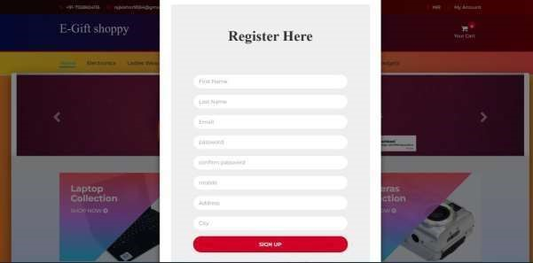

<?php session_start(); include "db.php";

if (isset($_POST["f_name"])) {

$f_name = $_POST["f_name"];

$l_name = $_POST["l_name"];

$email = $_POST['email'];

$password = $_POST['password'];

$repassword = $_POST['repassword'];

$mobile = $_POST['mobile'];

$address1 = $_POST['address1'];

$address2 = $_POST['address2'];

$name = "/^[a-zA-Z ]+$/";

$emailValidation = "/^[_a-z0-9-]+(\.[_a-z0-9-]+)*@[a-z0-9]+(\.[a- z]{2,4})$/";

$number = "/^[0-9]+$/";

if(empty($f_name) || empty($l_name) || empty($email) || empty($password) || empty($repassword) || empty($mobile) || empty($address1) || empty($address2)){

echo "

<div class='alert alert-warning'>

<a href='#' class='close' data-dismiss='alert' aria-

label='close'>&times;</a><b>PLease Fill all fields..!</b> </div> "; exit();

} else { if(!preg_match($name,$f_name)){ echo "

<div class='alert alert-warning'>

<a href='#' class='close' data-dismiss='alert' aria-

label='close'>&times;</a>

<b>this $f_name is not valid..!</b>

</div> "; exit(); } if(!preg_match($name,$l_name)){ echo "

<div class='alert alert-warning'>

<a href='#' class='close' data-dismiss='alert' aria-

label='close'>&times;</a>

<b>this $l_name is not valid..!</b>

</div> "; exit(); } if(!preg_match($emailValidation,$email)){ echo "

<div class='alert alert-warning'>

<a href='#' class='close' data-dismiss='alert' aria-

label='close'>&times;</a>

<b>this $email is not valid..!</b>

</div> "; exit(); } if(strlen($password) < 9 ){ echo "

<div class='alert alert-warning'>

<a href='#' class='close' data-dismiss='alert' aria-

label='close'>&times;</a>

<b>Password is weak</b>

</div> "; exit(); }

if(strlen($repassword) < 9 ){ echo "

<div class='alert alert-warning'>

<a href='#' class='close' data-dismiss='alert' aria-

label='close'>&times;</a>

<b>Password is weak</b>

</div> "; exit(); } if($password != $repassword){ echo "

<div class='alert alert-warning'>

<a href='#' class='close' data-dismiss='alert' aria-

label='close'>&times;</a>

<b>password is not same</b>

</div>

"; } if(!preg_match($number,$mobile)){ echo "

<div class='alert alert-warning'>

<a href='#' class='close' data-dismiss='alert' aria-

label='close'>&times;</a>

<b>Mobile number $mobile is not valid</b> </div> "; exit(); } if(!(strlen($mobile) == 10)){ echo "

<div class='alert alert-warning'>

<a href='#' class='close' data-dismiss='alert' aria-

label='close'>&times;</a>

<b>Mobile number must be 10 digit</b>

</div> "; exit();

}

//existing email address in our database

$sql = "SELECT user_id FROM user_info WHERE email = '$email' LIMIT 1" ;

$check_query = mysqli_query($con,$sql); $count_email = mysqli_num_rows($check_query); if($count_email > 0){ echo "

<div class='alert alert-danger'>

<a href='#' class='close' data-dismiss='alert' aria-

label='close'>&times;</a>

<b>Email Address is already available Try Another email

address</b>

</div>

"; exit();

} else {

$sql = "INSERT INTO `user_info`

(`user_id`, `first_name`, `last_name`, `email`,

`password`, `mobile`, `address1`, `address2`) VALUES (NULL, '$f_name', '$l_name', '$email',

'$password', '$mobile', '$address1', '$address2')";

$run_query = mysqli_query($con,$sql);

$_SESSION["uid"] = mysqli_insert_id($con);

$_SESSION["name"] = $f_name;

$ip_add = getenv("REMOTE_ADDR");

$sql = "UPDATE cart SET user_id = '$_SESSION[uid]' WHERE ip_add='$ip_add' AND user_id = -1"; if(mysqli_query($con,$sql)){ echo "register_success"; echo "<script> location.href='store.php'; </script>"; exit;

}

}

}

}

**Dishes.php:**

<div class="page-wrapper">

<div class="top-links">

<div class="container">

<ul class="row links">

<liclass="col-xs-12col-sm-4link-item"><span>1</span><ahref="Shop.php">Choose Gift</a></li>

<liclass="col-xs-12col-sm-4link-itemactive"><span>2</span><a href="dishes.php?res_id=<?php echo $_GET['res_id']; ?>">Pick Your favorite Gift</a></li>

<li class="col-xs-12 col-sm-4 link-item"><span>3</span><a href="#">Order and Pay</a></li></ul></div></div>

<?php $ress= mysqli_query($db,"select * from Gift where rs_id='$_GET[res_id]'");

$rows=mysqli_fetch_array($ress);?>

<section class="inner-page-hero bg-image" data-image-src="images/img/ibg.jpg">

<div class="profile">

<div class="container">

<div class="row">

<div class="col-xs-12 col-sm-12 col-md-4 col-lg-4 profile-img">

<div class="image-wrap">

<figure><?php echo '<img src="admin/Res_img/'.$rows['image'].'" alt="Gift logo">'; ?></figure></div></div>

<div class="col-xs-12 col-sm-12 col-md-8 col-lg-8 profile-desc">

<div class="pull-left hero-text font-white">

<h6><a href="#"><?php echo $rows['title']; ?></a></h6>

<p><?php echo $rows['address']; ?></p>

</div>

</div></div> </div></div></section>

<div class="breadcrumb">

<div class="container"></div></div>

<div class="container m-t-30">

<div class="row">

<div class="col-xs-12 col-sm-4 col-md-4 col-lg-3">

<div class="widget widget-cart">

<div class="widget-heading">

<h3 class="widget-title text-dark">Your Cart</h3>

<div class="clearfix"></div> </div>

<div class="order-row bg-white">

<div class="widget-body">

<?php

$item_total = 0;

foreach ($_SESSION["cart_item"] as $item)

{?>

<div class="title-row">

<?php echo $item["title"]; ?><a href="dishes.php?res_id=<?php echo $_GET['res_id']; ?>&action=remove&id=<?php echo $item["d_id"]; ?>">

<i class="fa fa-trash pull-right"></i></a></div>

<div class="form-group row no-gutter">

<div class="col-xs-8">

<input type="text" class="form-control b-r-0" value=<?php echo "Rs.".$item["price"]; ?> readonly id="exampleSelect1"></div>

<div class="col-xs-4">

<input class="form-control" type="text" readonly value='<?php echo $item["quantity"]; ?>' id="example-number-input"> </div> </div>

<?php

$item_total += ($item["price"]*$item["quantity"]);}?></div></div>

<div class="widget-body">

<div class="price-wrap text-xs-center">

<p>TOTAL</p>

<h3 class="value"><strong><?php echo "Rs ".$item_total; ?></strong></h3>

<p>Free Delivery above 500</p>

<?php

if($item_total==0){

?>

<a href="checkout.php?res_id=<?php echo $_GET['res_id'];?>&action=check" class="btn btn-danger btn-lg disabled">Checkout</a>

<?php

}else{ ?>

<a href="checkout.php?res_id=<?php echo $_GET['res_id'];?>&action=check" class="btn btn-success btn-lg active">Checkout</a>

<?php }?></div></div></div></div>

<div class="col-md-8">

<div class="menu-widget" id="2">

<div class="widget-heading">

<h3 class="widget-title text-dark">

MENU <a class="btn btn-link pull-right" data-toggle="collapse" href="#popular2" aria-expanded="true">

<i class="fa fa-angle-right pull-right"></i>

<i class="fa fa-angle-down pull-right"></i></a></h3>

<div class="clearfix"></div></div>

<div class="collapse in" id="popular2">

<?php

$stmt = $db->prepare("select * from dishes where rs_id='$_GET[res_id]'");

$stmt->execute();

$products = $stmt->get_result();

if (!empty($products)) {

foreach($products as $product){?>

<div class="Gift-item">

<div class="row">

<div class="col-xs-12 col-sm-12 col-lg-8">

<form method="post" action='dishes.php?res_id=<?php echo $_GET['res_id'];?>&action=add&id=<?php echo $product['d_id']; ?>'>

<div class="rest-logo pull-left">

<a class="Gift-logo pull-left" href="#"><?php echo '<img src="admin/Res_img/dishes/'.$product['img'].'" alt="Gift logo">'; ?></a></div>

<div class="rest-descr">

<h6><a href="#"><?php echo $product['title']; ?></a></h6>

<p> <?php echo $product['slogan']; ?></p></div></div>

<div class="col-xs-12 col-sm-12 col-lg-3 pull-right item-cart-info">

<span class="price pull-left" >Rs<?php echo $product['price']; ?></span>

<input class="b-r-0" type="text" name="quantity" style="margin-left:30px;" value="1" size="2" />

<input type="submit" class="btn theme-btn" style="margin-left:40px;" value="Add To Cart" /></div></form></div></div><?php}}?></div></div></div></div></div>

**Gift.php**

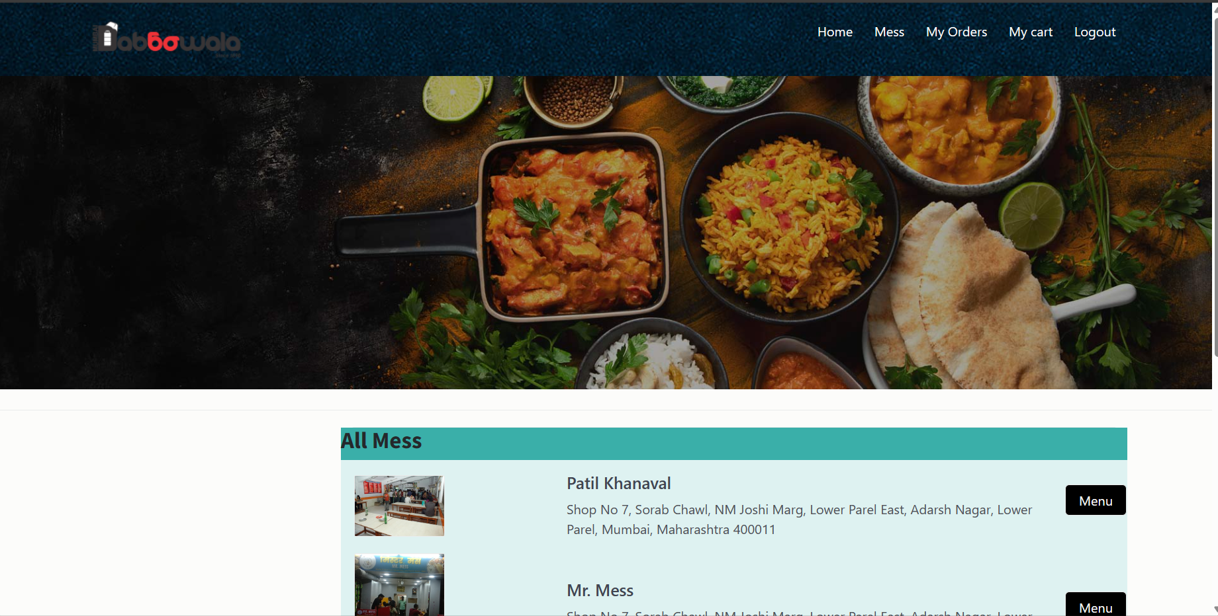

<div class="page-wrapper">

<div class="top-links">

<div class="container">

<ul class="row links">

<li class="col-xs-12 col-sm-4 link-item active"><span>1</span><a href="#">Choose Gift</a></li>

<li class="col-xs-12 col-sm-4 link-item"><span>2</span><a href="#">Pick Your favorite Gift</a></li>

<li class="col-xs-12 col-sm-4 link-item"><span>3</span><a href="#">Order and Pay</a></li></ul></div></div>

<div class="inner-page-hero bg-image" data-image-src="images/img/pimg.jpg">

<div class="container"> </div></div>

<div class="result-show">

<div class="container">

<div class="row"></div></div> </div>

<section class="Shop-page">

<div class="container">

<div class="row">

<div class="col-xs-12 col-sm-5 col-md-5 col-lg-3"></div>

<div class="col-xs-12 col-sm-7 col-md-7 col-lg-9">

<div class="bg-gray Gift-entry">

<div class="row">

<?php

$ress= mysqli_query($db,"select * from Gift");

while($rows=mysqli_fetch_array($ress)){

echo' <div class="col-sm-12 col-md-12 col-lg-8 text-xs-center text-sm-left">

<div class="entry-logo">

<aclass="img-fluid"href="dishes.php?res_id='.$rows['rs_id'].'"><img src="admin/Res_img/'.$rows['image'].'" alt="Gift logo"></a></div>

<!-- end:Logo -->

<div class="entry-dscr">

<h5><ahref="dishes.php?res_id='.$rows['rs_id'].'">'.$rows['title'].'</a></h5> <span>'.$rows['address'].'</span></div>

<!-- end:Entry description -->

</div>

<div class="col-sm-12 col-md-12 col-lg-4 text-xs-center">

<div class="right-content bg-white">

<div class="right-review">

<a href="dishes.php?res_id='.$rows['rs_id'].'" class="btn btn-purple">View Menu</a> </div>

</div>

<!-- end:right info -->

</div>';

}

?>

</div>

</div>

</div>

</div>

</div>

</div>

</section>

**Razorpay.php:**

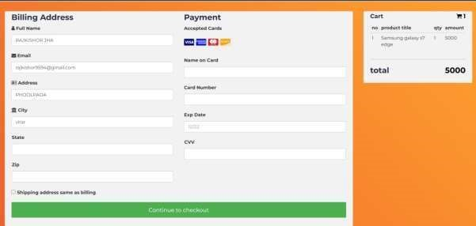

<!DOCTYPE html>

<html lang="en">

<?php

include("connection/connect.php");

session_start();

require 'vendor/autoload.php'; // Include Razorpay SDK

use Razorpay\Api\Api;

$api = new Api('rzp_test_DM3gWFYJmst6Yu', 'XAXkTRokhDJk0ZQXAawMhnD9');

$order = $api->order->create(

array(

'receipt' => 'order_rcptid_' . time(),

'amount' => $_SESSION['finalamount'] * 100, // Amount in paise

'currency' => 'INR',));

if (!empty($order['id'])) {

$_SESSION['order_id'] = $order['id'];

?>

<div style="display:none">

<form action="orderconfirm.php" method="get">

<script src="https://checkout.razorpay.com/v1/checkout.js"

data-key="<?php echo 'rzp_test_DM3gWFYJmst6Yu'; ?>"

data-amount="<?php echo $_SESSION['finalamount'] * 100; ?>"

data-currency="INR"

data-order_id="<?php echo $order['id']; ?>"

data-buttontext="Pay Now">

data-name="<?php 'Gift Store'; ?>";

id="razorpayButton">

<?php

$Method="Online";

$pstatus="Paid";

$GST=$_SESSION["item_price"]*18/100;

foreach ($_SESSION["cart_item"] as $item){

//Query for inserting value in users_orders table//

$SQL="insert into users_orders(u_id,title,quantity,price) values('".$_SESSION["user_id"]."','".$_SESSION['Final-Title']."','".$_SESSION['Final-Quantity']."','".$_SESSION['item_price']."')";

mysqli_query($db,$SQL);

//Query for inserting value in billrecords table//

$BILL="INSERT INTO `billrecords` (`username`, `ItemName`, `quantity`, `itemprice`, `d_charge`,`gst`,`method`,`paymentstatus`)VALUES('".$_SESSION['usre_name']."','".$_SESSION['Final-Title']."','".$_SESSION['Final-Quantity']."','".$_SESSION['item_price']."','".$_SESSION['charge']."','".$GST."','".$Method."','".$pstatus."')";

mysqli_query($db,$BILL);}?>

</script>

<buttontype="submit"name="submit"style="display: none;" id="submitBtn">Submit</button> </form> </div>

<script>

window.onload = function() {

// // Select the button element

var button = document.getElementById('submitBtn');

// // Define a function to simulate a click event

function clickButton() {

button.click(); // Trigger a click event on the button }

// // Call the clickButton function

clickButton(); };

</script>

<?php}?>

**Productaction.php**

<?php

if(!empty($_GET["action"])) {

$productId = isset($_GET['id']) ? htmlspecialchars($_GET['id']) : '';

$quantity = isset($_POST['quantity']) ? htmlspecialchars($_POST['quantity']) : '';

switch($_GET["action"]){

case "add":

if(!empty($quantity)) {

$stmt = $db->prepare("SELECT * FROM dishes where d_id= ?");

$stmt->bind_param('i',$productId);

$stmt->execute();

$productDetails = $stmt->get_result()->fetch_object();

$itemArray=array($productDetails->d_id=>array('title'=>$productDetails->title, 'd_id'=>$productDetails->d_id, 'quantity'=>$quantity, 'price'=>$productDetails->price));

if(!empty($_SESSION["cart_item"])) {

if(in_array($productDetails->d_id,array_keys($_SESSION["cart_item"]))) {

foreach($_SESSION["cart_item"] as $k => $v) {

if($productDetails->d_id == $k) {

if(empty($_SESSION["cart_item"][$k]["quantity"])) {

$_SESSION["cart_item"][$k]["quantity"] = 0;}

$_SESSION["cart_item"][$k]["quantity"] += $quantity;}}}

else {

$_SESSION["cart_item"] = $_SESSION["cart_item"] + $itemArray;

}else {

$_SESSION["cart_item"] = $itemArray;}}

break;

case "remove":

if(!empty($_SESSION["cart_item"])){

foreach($_SESSION["cart_item"] as $k => $v) {

if($productId == $v['d_id'])

unset($_SESSION["cart_item"][$k]);}}

break;

case "empty":

unset($_SESSION["cart_item"]);

break;

case "check":

header("location:checkout.php");

break;}}

**Checkout.php**

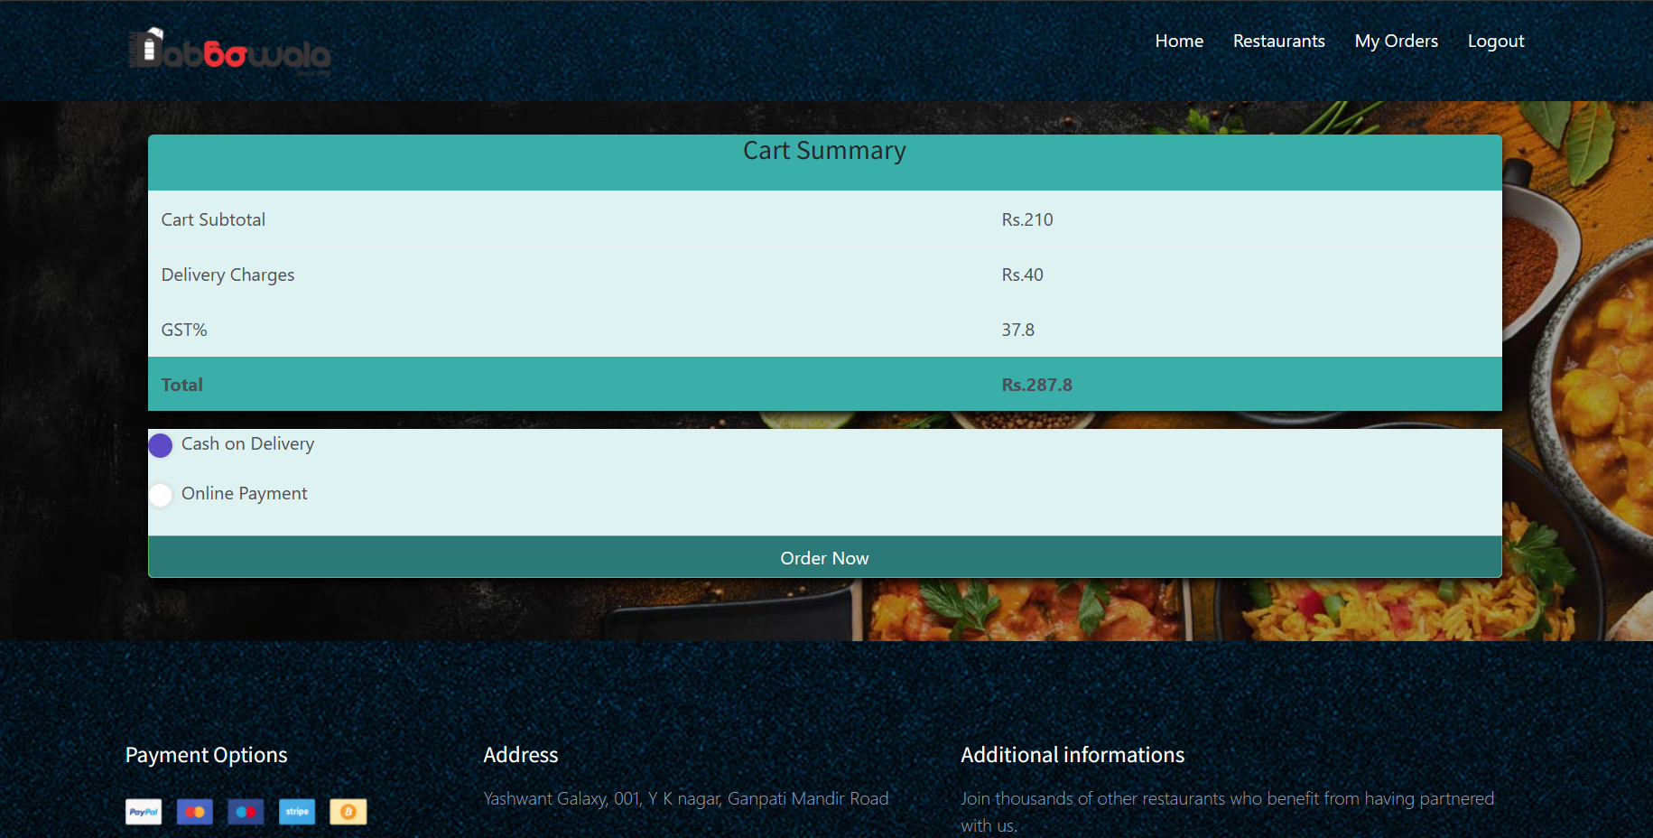

<!DOCTYPE html>

<html lang="en">

<?php

include("connection/connect.php");

include_once 'product-action.php';

session_start();

function function_alert() {

echo "<script>alert('Thank you. Your Order has been placed!');</script>";

echo "<script>window.location.replace('your_orders.php');</script>"; }

if(empty($_SESSION["user_id"])){

header('location:login.php');

}else{

foreach ($_SESSION["cart_item"] as $item){

$item_total += ($item["price"]*$item["quantity"])

if($_POST['submit']){

$pstatus="Unpaid";

$Method="COD";

$gst=$item["price"]*18/100;

// $_SESSION['Method']=$Method;

if($_POST['MOD']==="COD"){

//Query for inserting value in users_orders table//

$SQL="insertintousers_orders(u_id,title,quantity,price)values('".$_SESSION["user_id"]."','".$item["title"]."','".$item["quantity"]."','".$item['price']."')";mysqli_query($db,$SQL);

//Query for inserting value in billrecords table//

$BILL="INSERTINTO `billrecords` (`username`, `ItemName`, `quantity`, `itemprice`, `d_charge`, `gst`,`method`,`paymentstatus`)VALUES('".$_SESSION['username']."','".$item["title"]."','".$item["quantity"]."','".$item["price"]."','".$_SESSION['charge']."','".$gst."','".$Method."','".$pstatus."')";

mysqli_query($db,$BILL);

unset($_SESSION["cart_item"]);

unset($item["title"]);

unset($item["quantity"]);

unset($item["price"]);

function_alert();

header("location:orderconfirmcod.php");}

if($_POST['MOD']==="Online_Payment"){

unset($_SESSION["cart_item"]);

$_SESSION['item_price']=$item["price"];

$_SESSION['Final-Title']=$item["title"];

$_SESSION['Final-Quantity']=$item["quantity"];

header("location:payment.php");}}}?>

<div class="page-wrapper">

<div class="top-links">

<div class="container">

<ul class="row links">

<liclass="col-xs-12col-sm-4link-item"><span>1</span><a href="Shop.php">Choose Gift</a></li>

<li class="col-xs-12 col-sm-4 link-item "><span>2</span><a href="#">Pick Your favorite Gift</a></li>

<liclass="col-xs-12col-sm-4link-itemactive"><span>3</span><a href="checkout.php">Order and Pay</a></li></ul></div></div>

<div class="container">

<span style="color:green;"><?php echo $success; ?></span></div>

<div class="container m-t-30">

<form action="" method="post">

<div class="widget clearfix">

<div class="widget-body">

<form method="post" action="#">

<div class="row">

<div class="col-sm-12">

<div class="cart-totals margin-b-20">

<div class="cart-totals-title">

<h4>Cart Summary</h4> </div>

<div class="cart-totals-fields">

<table class="table">

<tbody><tr>

<td>Cart Subtotal</td>

<td> <?php echo "Rs.".$item_total; ?></td> </tr>

<tr>

<td>Delivery Charges</td>

<td><?php $charge="40";

echo "Rs.".$charge; session_start(); $_SESSION['charge']=$charge;?></td> </tr>

<tr>

<td>GST%</td>

<td><?php echo $gst=$item_total*18/100;?></td></tr>

<tr>

<td class="text-color"><strong>Total</strong></td>

<tdclass="text-color"><strong><?php echo "Rs.".$final_price=$item_total+$charge+$gst; session_start();$_SESSION['final_price']=$final_price;?></strong></td></tr></tbody> </table></div></div>

<div class="payment-option">

<ul class=" list-unstyled">

<li>

<label class="custom-control custom-radio m-b-20">

<input name="MOD" id="radioStacked1" checked value="COD" type="radio" class="custom-control-input"> <span class="custom-control-indicator"></span> <span class="custom-control-description">Cash on Delivery</span></label> </li><li>

<label class="custom-control custom-radio m-b-10">

<input name="MOD" type="radio" checked value="Online_Payment" class="custom-control-input"> <span class="custom-control-indicator"></span> <span class="custom-control-description">Online Payment<img src="images/paypal.jpg" alt="" width="90"></span> </label>

</li></ul>

<p class="text-xs-center"> <input type="submit" name="submit" class="btn btn-success btn-block" value="Order Now"> </p> </div></form></div> </div></div></div></form></div>

**Paymentdetails.php:**

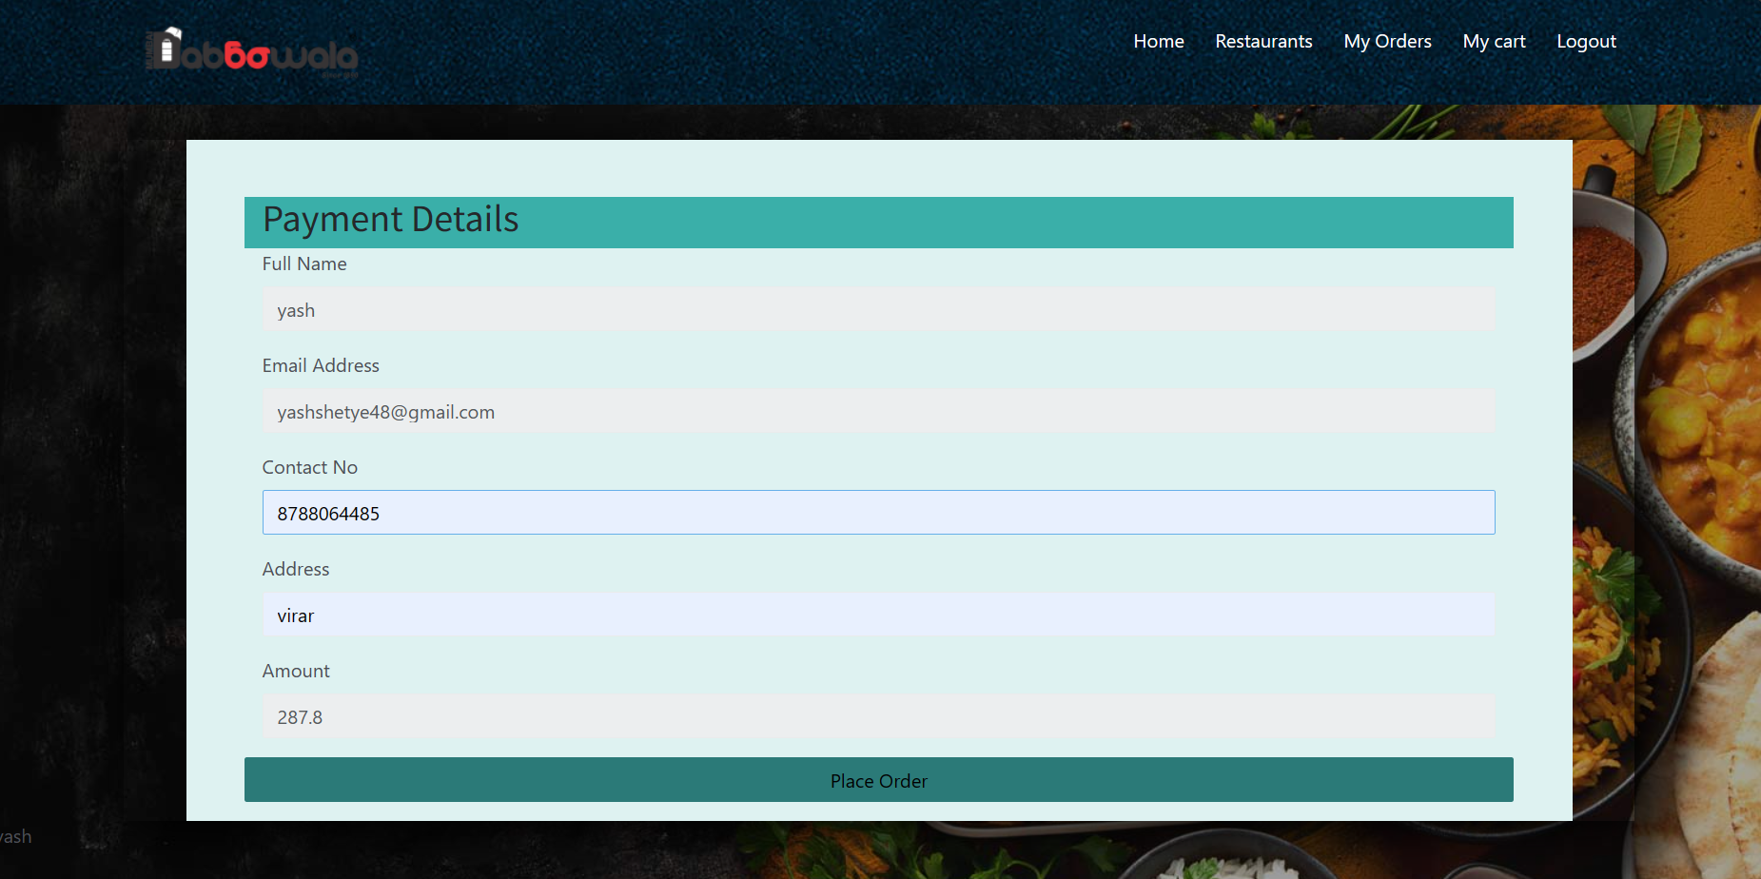

<div class="page-wrapper">

<div class="container" style="margin-top:50px; box-shadow:7px 7px 40px 3px black;">

<div class="container bg-white pt-3" style="background-color:#def2f1;">

<div class="container text-center" style="background-color:#3aafa9;">

<h2>Payment Details</h2></div>

<form action="" method="post" >

<div class="container" style="background-color:#def2f1;"><div class="form-group">

<label for="exampleInputEmail1">Full Name</label>

<input class="form-control" type="text" name="username" id="example-text-input" value="<?php echo $_SESSION['username'];?>" readonly>

<?php session_start(); $_SESSION['user_name']=$_POST["username"];?></div>

<div class="form-group">

<label for="exampleInputEmail1">Email Address</label>

<input class="form-control" type="email" name="Email" value="<?php session_start(); echo $_SESSION['user_email'];?>" id="example-text-input" readonly> </div>

<div class="form-group">

<label for="exampleInputEmail1">Contact No</label>

<input class="form-control" type="text" name="Contact No" value="<?php ?>" id="example-text-input-2" required> </div>

<div class="form-group">

<label for="exampleInputEmail1">Address</label>

<input class="form-control" type="text" name="Address" id="example-tel-input-3" required></div>

<div class="form-group">

<label for="exampleInputEmail1">Amount</label>

<inputclass="form-control"type="text"name="Amount"value="<?php session_start();echo$finalamount=$_SESSION['final_price']; $_SESSION['finalamount']=$finalamount;?>" id="example-tel-input-3" readonly>

</div>

<div class="row">

<div class="">

<pclass="text-xs-center"><inputtype="submit" value="Place Order" name="place_order"class="btn btn-block style="backgroundcolor:#2b7a78;"onmouseover="this.style.backgroundColor='#3aafa9';" onmouseout="this.style.backgroundColor='#2b7a78';" > </p>

</div></div></div></form></div></div>

**MyProfile.php:**

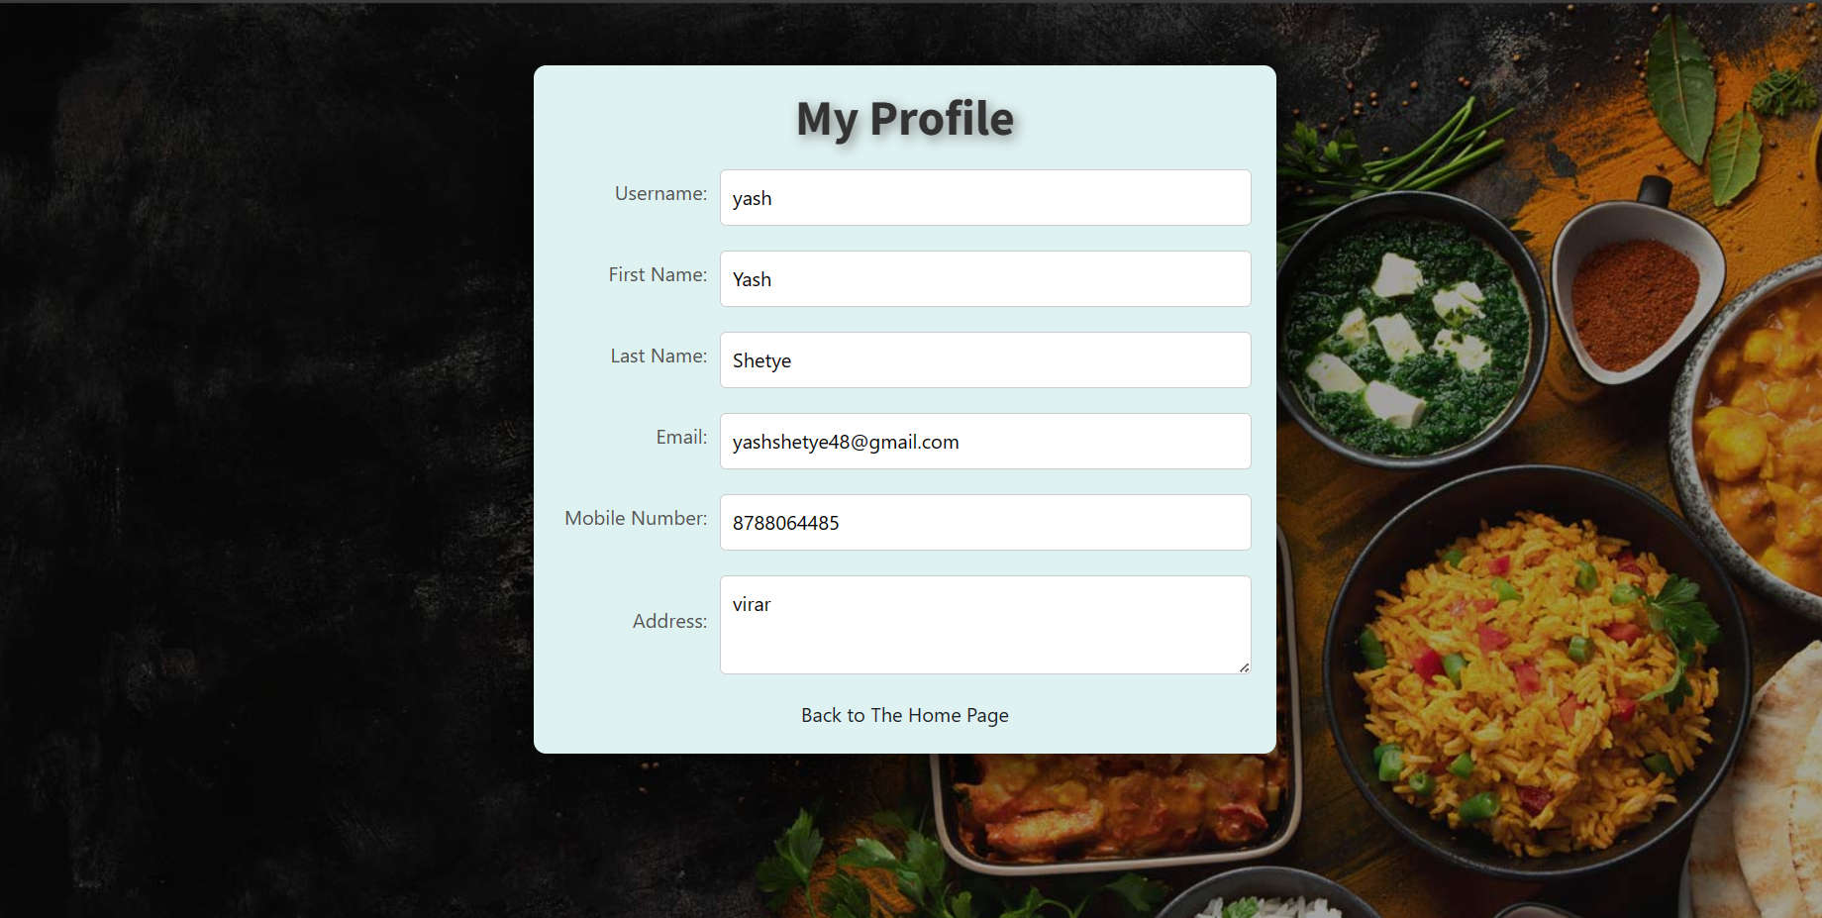

</head>

<body style="background-image: url('images/img/pimp.jpg');">

<div class="containers" style="box-shadow:4px 4px 60px 2px black;background-color:#def2f1;">

<h1 style="text-shadow:3px 3px 10px grey;"><b>My Profile</b></h1>

<form id="profileForm">

<div class="form-group">

<label for="username">Username:</label>

<input type="text" id="username" name="username" value="<?php echo $row["username"];?>" Readonly></div>

<div class="form-group">

<label for="firstname">First Name:</label>

<input type="text" id="firstname" name="firstname" value="<?php echo $row["f_name"];?>" Readonly></div>

<div class="form-group">

<label for="lastname">Last Name:</label>

<input type="text" id="lastname" name="lastname" value="<?php echo $row["l_name"];?>" Readonly></div>

<div class="form-group">

<label for="email">Email:</label>

<input type="email" id="email" name="email" value="<?php echo $row["email"];?>" Readonly></div>

<div class="form-group">

<label for="mobileno">Mobile Number:</label>

<input type="tel" id="mobileno" name="mobileno" value="<?php echo $row["phone"];?>" Readonly></div>

<div class="form-group">

<label for="address">Address:</label>

<textarea id="address" name="address" Readonly><?php echo $row["address"];?></textarea>

</div>

<a href="index.php" style="text-align:center;color:#17252a;">Back to The Home Page</a>

</form></div></body></html>

**BillRecords.php:**

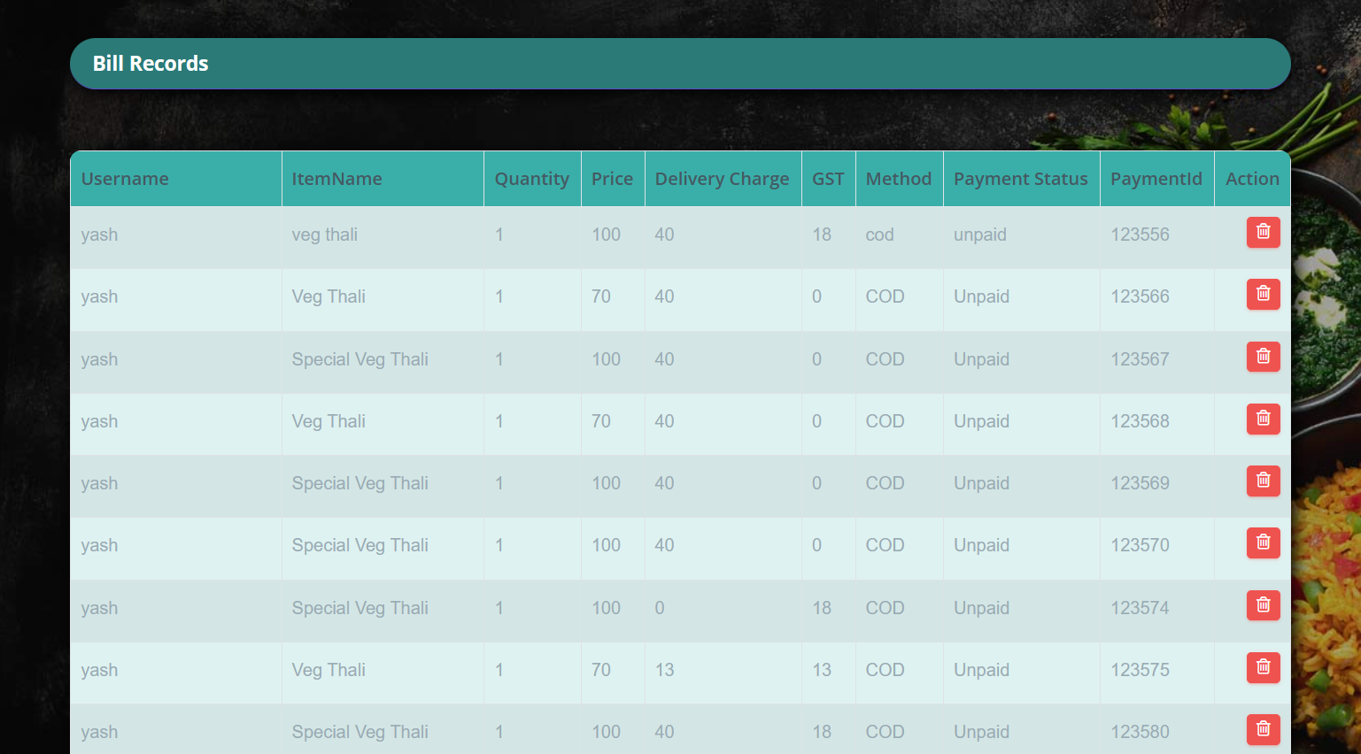

<div class="page-wrapper" style="background-image:url('imagesadmin/pimp.jpg');">

<div class="container-fluid">

<div class="row">

<div class="col-12">

<div class="col-lg-12">

<div class="card card-outline-primary" style="background-color:transparent;">

<div class="card-header" style="display:flex;background-color:#2b7a78;box-shadow:4px 4px 15px black;border-radius:25px;margin-bottom:15px;">

<h4 class="m-b-0 text-white" style="text-align:center;"><b>Bill Records</b></h4> </div>

<?php

if(isset($_POST['submit'])){

header("location:print.php");}?>

<div class="table-responsive m-t-40" style="border-radius:10px;box-shadow:4px 4px 15px black;">

<table id="myTable" class="table table-bordered table-striped">

<thead class="thead" style="background-color:#3aafa9;">

<tr>

<th>Username</th>

<th>ItemName</th>

<th>Quantity</th>

<th>Price</th> <th>Delivery Charge</th> <th>GST</th> <th>Method</th> <th>Payment Status </th>

<th>PaymentId</th>

<th>Action</th>

</tr>

</thead >

<tbody style="background-color:#def2f1;">

<?php

session_start();

$stmt = $db->prepare("SELECT * FROM BillRecords");

$stmt->execute();

$result = $stmt->get_result();

if ($result->num_rows > 0) {

// Output data of each r

while ($row = $result->fetch_assoc()) {

echo "<tr>";

echo "<td>" . $row["username"] . "</td>";

echo "<td>" . $row["ItemName"] . "</td>";

echo "<td>" . $row["quantity"] . "</td>";

echo "<td>" . $row["itemprice"] . "</td>";

echo "<td>" . $row["d_charge"] . "</td>";

echo "<td>" . $row["gst"] . "</td>";

echo "<td>" . $row["method"] . "</td>";

echo "<td>" . $row["paymentstatus"] . "</td>";

echo "<td>" . $row["paymentid"] . "</td>

echo "<td><a href='delBill.php?delBill=" . $row['paymentid'] . "' onclick='return confirm(\"Are you sure?\");' class='btn btn-danger btn-flat btn-addon btn-xs m-b-10'><i class='fa fa-trash-o' style='font-size:16px'></i></a></td>";

echo "</tr>";

// Set session variable here

$_SESSION['paymentId'] = $row["paymentid"];}

} else {

echo "<tr><td colspan='10'>No records found</td></tr>";}

$stmt->close();?>

</tbody>

</table></div></div></div></div</div>

<div class="print" style="display:flex;justify-content:center;">

<form action="print.php" method="post" target="_blank">

<input type="submit" value="print" name="print" class="btn btn-success">

</form></div></div></div></div></div>

**Print.php:**

<?php

// Include the main TCPDF library (search for installation path).

require_once('TCPDF/config/tcpdf_config.php');

require_once('TCPDF/tcpdf.php');

session_start();

// extend TCPF with custom functions

class MYPDF extends TCPDF {

// Load table data from file

public function LoadData() {

include("../connection/connect.php");

$sql = "SELECT username, ItemName, quantity, itemprice FROM billrecords";

$result = $db->query($sql);

$Data = array();

if ($result->num_rows > 0) {

while ($row = $result->fetch_assoc()) {

$Data[] = array(

'username' => $row["username"],

'ItemName' => $row["ItemName"],

'quantity' => $row["quantity"],

'itemprice' => $row["itemprice"]

);}}

$db->close();

return $Data;}

// Colored table

public function ColoredTable($header,$data) {

// Colors, line width and bold font

$this->setFillColor(255, 0, 0);

$this->setTextColor(255);

$this->setDrawColor(128, 0, 0);

$this->setLineWidth(0.3);

$this->setFont('', 'B');

// Header

$w = array(55, 50, 40, 35);

$num_headers = count($header);

for($i = 0; $i < $num_headers; ++$i) {

$this->Cell($w[$i], 7, $header[$i], 1, 0, 'C', 1);}

$this->Ln();

// Color and font restoration

$this->setFillColor(224, 235, 255);

$this->setTextColor(0);

$this->setFont('');

// Data

$fill = 0;

foreach($data as $row) {

$this->Cell($w[0], 6, $row['username'], 'LR', 0, 'L', $fill);

$this->Cell($w[1], 6, $row['ItemName'], 'LR', 0, 'L', $fill);

$this->Cell($w[2], 6, number_format($row['quantity']), 'LR', 0, 'R', $fill);

$this->Cell($w[3], 6, number_format($row['itemprice']), 'LR', 0, 'R', $fill);

$this->Ln();

$fill=!$fill;}

$this->Cell(array_sum($w), 0, '', 'T');}}

// create new PDF document

$pdf = new MYPDF(PDF_PAGE_ORIENTATION, PDF_UNIT, PDF_PAGE_FORMAT, true, 'UTF-8', false);

// set document information

$pdf->setCreator(PDF_CREATOR);

$pdf->setAuthor('Yash Shetye');

$pdf->setTitle('');

$pdf->setSubject('TCPDF Tutorial');

$pdf->setKeywords('TCPDF, PDF, example, test, guide');

// set default header data

$pdf->setHeaderData(PDF_HEADER_LOGO, PDF_HEADER_LOGO_WIDTH,PDF_HEADER_TITLE,PDF_HEADER_STRING);

// set header and footer fonts

$pdf->setHeaderFont(Array(PDF_FONT_NAME_MAIN, '', PDF_FONT_SIZE_MAIN));

$pdf->setFooterFont(Array(PDF_FONT_NAME_DATA, '', PDF_FONT_SIZE_DATA));

// set default monospaced font

$pdf->setDefaultMonospacedFont(PDF_FONT_MONOSPACED);

// set margins

$pdf->setMargins(PDF_MARGIN_LEFT, PDF_MARGIN_TOP, PDF_MARGIN_RIGHT);

$pdf->setHeaderMargin(PDF_MARGIN_HEADER);

$pdf->setFooterMargin(PDF_MARGIN_FOOTER);

// set auto page breaks

$pdf->setAutoPageBreak(TRUE, PDF_MARGIN_BOTTOM);

// set image scale factor

$pdf->setImageScale(PDF_IMAGE_SCALE_RATIO);

// set some language-dependent strings (optional)

if (@file_exists(dirname(__FILE__).'/lang/eng.php')) {

require_once(dirname(__FILE__).'/lang/eng.php');

$pdf->setLanguageArray($l);}

// set font

$pdf->setFont('helvetica', '', 12);

// add a page

$pdf->AddPage();

// column titles

$header = array('username', 'ItemName', 'quantity', 'itemprice');

// data loading

$data = $pdf->LoadData();

// print colored table

$pdf->ColoredTable($header, $data);

// ---------------------------------------------------------

// close and output PDF document

$pdf->Output('Salesdetails.pdf', 'I');

**B)CODING EFFICIENCY**

The speed and user experience of a OnlineGiftService website can be significantly impacted by how efficiently its code is written.

The following variables can impact a matchmaking website's algorithm efficiency:

To ensure efficient code for an Electronic-Gift Shop project, consider implementing the following practices:

1. Database Optimization:

- Use proper indexing for frequently queried fields.

- Optimize database queries to reduce the number of database calls.

- Normalize the database schema to avoid redundancy and improve data consistency.

2. Server Architecture:

- Implement load balancing to distribute incoming traffic evenly across servers.

- Use scalable server architecture to handle varying levels of user demand.

- Employ efficient server-side scripting languages and frameworks like Node.js, Django, or Flask.

3. Code Architecture:

- Follow a modular and structured code architecture pattern such as MVC (Model-View-Controller) or similar.

- Use design patterns like Singleton, Factory, or Repository to promote code reusability and maintainability.

- Keep the codebase organized and well-documented to enhance readability and ease of maintenance.

4. Caching:

- Utilize caching mechanisms for frequently accessed data to reduce database load.

- Implement caching at different levels such as database query caching, object caching, or full-page caching.

- Employ caching strategies like time-based expiration or cache invalidation to ensure data consistency.

5. Front-end Optimization:

- Minify and concatenate CSS, JavaScript, and HTML files to reduce load times.

- Optimize images and other media assets to decrease page load times.

- Implement lazy loading for images and resources to improve initial page render times.

- Use Content Delivery Networks (CDNs) to deliver static assets quickly to users worldwide.

Additionally, continuously monitor and analyze the performance of the application . Regularly conduct performance testing and optimization iterations to address any bottlenecks and enhance the overall speed and user experience of the Electronic-Gift Shop website.

**5.3.TESTING**

**5.3.1 UNIT TESTING**

Unit testing is a crucial aspect of software development, ensuring that individual modules or units of code function correctly in isolation. In the context of our OnlineGiftService, unit testing focuses on verifying the functionality of each module independently before integrating them into the system as a whole. Here's how unit testing applies to the various modules:

User Registration and Authentication:

Unit tests for this module would involve verifying the creation of user accounts, proper storage of user data, and the authentication process. Tests would include scenarios such as valid registration, invalid inputs, password encryption, and session management.

Search and Filtering:

Unit tests would ensure that the search and filtering functionalities return correct results based on different criteria.

Order and Cart Management:

Unit tests would focus on functionalities such as adding items to the cart, modifying quantities, and processing orders. Tests would cover scenarios like adding items with different quantities, removing items from the cart, and calculating order totals accurately.

Admin Dashboard:

Unit tests for the admin dashboard would validate functions related to user management, content moderation, and system configuration. Tests would include scenarios such as adding/removing users, verifying admin privileges, and updating system settings.

By thoroughly testing each module individually, developers can identify and address issues early in the development process, leading to a more robust and reliable online Gift ordering system.

**5.3.2.INTEGRATION TESTING**

Integration testing for the OnlineGiftService involves testing the interactions between different modules to ensure that they function together seamlessly as a cohesive system. Here's a brief overview of integration testing focusing on the key modules identified:

User Registration and Authentication Integration:

Verify that user registration and authentication functionalities integrate smoothly with other modules. Test scenarios where registered users can log in, view personalized menus, and place orders without encountering authentication issues.

Search and Filtering Integration:

Ensure that search and filtering functionalities seamlessly integrate with the module to provide users with relevant search results.

Order and Cart Management Integration:

Verify that the ordering and cart module integrates smoothly with menu browsing and selection functionalities. Test scenarios where users can add items to their cart, modify quantities, and proceed to checkout without encountering errors or inconsistencies.

Admin Dashboard Integration:

Verify that the admin dashboard module integrates effectively with user-facing functionalities and backend systems to manage the entire platform. Integration testing ensures that all modules of the online bookstore work together harmoniously to deliver a seamless and reliable user experience.

By thoroughly testing the integration between modules, developers can identify and address any issues or inconsistencies, ensuring the overall quality and functionality of the system.

**5.3.3.BETA TESTING**

Beta testing for the OnlineGiftService involves releasing the software to a limited group of external users to gather feedback, identify potential issues, and ensure the system's readiness for full-scale deployment. Here's a brief overview of beta testing referring to the key modules identified:

User Registration and Authentication Beta Testing:

Invite a group of external users to register accounts and authenticate themselves on the platform. Gather feedback on the registration process, ease of account creation, and any issues encountered during login.

Search and Filtering Beta Testing:

Encourage beta testers to utilize the search and filtering functionalities to find Shop and specific dishes based on different criteria. Evaluate the effectiveness of search results and the relevance of filtering options based on user feedback.

Order and Cart Management Beta Testing:

Prompt beta testers to add items to their carts, modify quantities, and proceed through the checkout process. Monitor the user experience during order placement, identifying any usability issues or technical glitches.

Admin Dashboard Beta Testing:

Provide administrators with access to the admin dashboard to manage user accounts, verify stores and moderate content.

Beta testing provides valuable insights into the usability, functionality, and performance of the online bookstore from real-world users' perspectives. By collecting feedback from beta testers and addressing their concerns, developers can ensure that the system meets user expectations and is ready for a successful launch

**5.3.4. TEST CASES**

|  |  |  |  |
| --- | --- | --- | --- |
| **Test case** | **Input specified** | **Expected result** | **Actual result** |
| User login | Email=”yash” Password=”123” | Verify and redirect to home page | Verify and redirect to home page |
| Admin Login | Username=”admin”  Password=”123456” | Verify and redirect on dashboard | Verify and redirect on dashboard. |
| Logout | User click on a logout button. | Redirect on login page | Redirect on login page |
| Register | Username=”” | Username is empty. | Username is empty. |
| Username=”yash111” | Registered successfully | Registered successfully |
| Firstname=””” | Enter a first Name | Enter a first Name |
| Lastname=”” | Enter a last name | Enter a last name |
| MobileNo= | Specify your mobile number | Specify your mobile number |
| MobileNo=12345678901 | Enter correct contact no | Enter correct contact no |
| Email=””” | Enter EmailId | Enter EmailId |
| Email=”abc” | Please enter valid email | Please enter valid email |
| Email=”[yash@gmail.com](mailto:yash@gmail.com)” | Message has been sent to you | Message has been sent to your email id |
| Set password =”” | Set a new password | Set a new password |
| Set password=”1111” | Password should not be less than 6  character | Password should not be less than 6  character |
| Set password=”123456” | Password is set | Password is set |

|  |  |  |  |
| --- | --- | --- | --- |
| **Test case** | **Input specified** | **Expected result** | **Actualresult** |
| Payment | Card Number=”” | Enter card number | Enter card number |
| Enter OTP=”” | Enter a OTP | Enter a OTP |
| Enter CVV=”” | Enter CVV | Enter CVV |
| Enter UPI=”” | Enter UPI | Enter UPI |
| Enter UPI=”yash” | Enter valid Upi Id | Enter valid Upi id |
| Enter UPI=”yash@okicici | Payment Successful | Payment successful |
| HomePage | User click on |  |  |
| 1)Mess | Redirect on the page of all mess. | Redirect on the page of all mess. |
| 2)MyOrders | Redirect on YourOrders page | Redirect on YourOrders page |
| 3)Mycart | Redirect on MyCart page | Redirect on MyCart page |
| 4)Logout | Redirect on Logout page | Redirect on Logout page |
| 5)MyProfile | Redirect on MyProfile page | Redirect on MyProfile page |
| 6)OrderNow Button | Redirect on the dishes page. | Redirect on the dishes page. |
| YourOrders | Uset click on the delete button | Order is getting deleted and redirect on YourOrder page. | Order is getting deleted and redirect on YourOrder page. |
| Dishes | User click on add to cart button. | Item should be added into the table. | Item is added into the table. |
| User ckick on the delete button. | Item should get deleted from cart. | Item should get deleted from cart. |
| User click on the checkout button. | Redirect on the check out page for confirm the order. | Redirect on the check out page for confirm the order. |
| Checkout | Calculating value according to Iem price.  1)Item price.  2)Gst  3)Total | Correct item price is should be there.  Gst should be calculated correctly according to Item price.  Amount should be calculated correctly. | Correct price is getting inserted.  Gst is calculating correctly according to Item price.  Total amount is to calculate correctly |
| User selecting the payment method and clicking on the order now.  1) Cash on Delivery.  2)Online Payment. | Order gets confirm and redirect on yourorder page.  Redirect on the payment Page. | Order gets confirm and redirect on yourorder page.  Redirect on the payment Page. |
| Admin dashboard | Admin Click On the All user tab | Show the details of all the user. | Show the details of all the user. |
| Admin click on the update user. | Redirect on the update user page. | Redirect on the update user page. |
| Admin click on the Add category. | Redirect on the add category page. | Redirect on the add category page. |
| Admin click on the Add Mess. | Redirect on the Add mess page. | Redirect on the Add mess page. |
| Admin Click on the Addmenu tab. | Redirect on the add menu page. | Redirect on the add menu page. |
| BillRecords | Admin click on the print button. | Generating the report in pdf format. | Generating the report in pdf format. |

**6.RESULT AND DISCUSSION**

**REPORTS:**

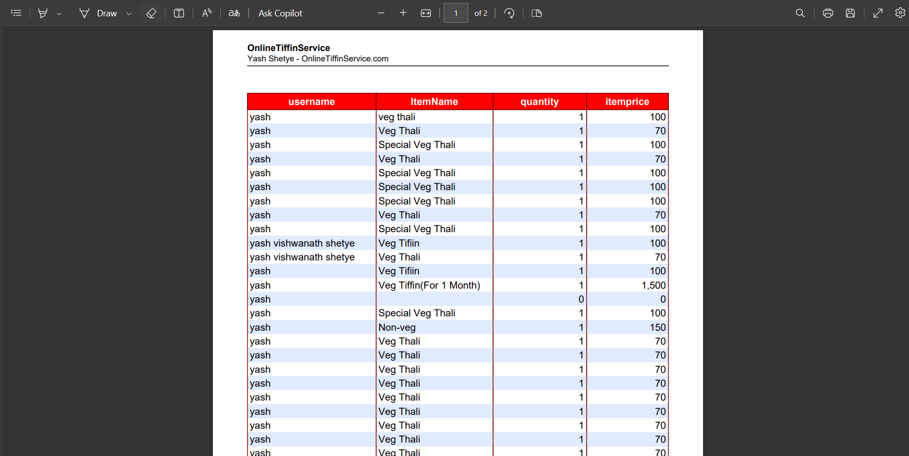

**6.1.TEST REPORTS**

|  |  |  |  |
| --- | --- | --- | --- |
| **Test case**  **Description** | **Test Steps** | **Result** | **Status** |
| User login | Verify and redirect to home page | Homepage is displayed | Verified |
| Admin Login | Verify and redirect on dashboard | Dashboard is displayed | Verified |
| Logout | Redirect on login page | Login page is displayed. | Verified |
| Register | Verify entered details and redirect and sending mail for successful registration and redirecting on login page. | Login page displayed | Verified |
| HomePage | Redirect on the page when user clicks the tabs on the navigation bar. | All pages are displayed properly. | Verified |
| Payment | After verifying details ,message should display as a payment successful and invoice should sent on the mail. | Message displayed and mail has been sent. | Verified |
| YourOrders | Redirecting the on the your order page where user can see the order history. | Your page displayed successfully. | Verified |
| Dishes | User adding the items in cart and  After clicking the checkout button it should be redirected on checkout page. | Item is adding into cart successfully and redirecting on checkout page. | Verified |
| Checkout | Calculating value according to Iem price and user click on the order now button after clicking order should be placed and redirect on the your order page. | All value are getting calculated correctly. | Verified |
| Billrecords | Admin clicks on print button and it generated the bill record in printable format. | Report generating successfully. | Verified |

Testing methodology: The testing methodology for the OnlineGiftService website is as follows:

➢ Requirement Analysis: Analysis of functional and non-functional requirements of the Online Bookstore application.

➢ Test Planning: Planning the test cases, test scenarios, and test data required for testing.

➢ Test Case Development: Developing test cases based on the requirements document.

➢ Test Execution: Executing the test cases and capturing the test results.

➢ Defect Management: Capturing, tracking, and resolving defects found during testing.

➢ Test Reporting: Creating test reports to summarize the testing activities and results.

As all test cases performed above passed and fully tested it functionality. All modules were working fine.

**6.2USER DOCUMENTAION**

Welcome to our OnlineGiftService This user documentation will guide you through the functionality of our platform to enhance your online Gift order experience.

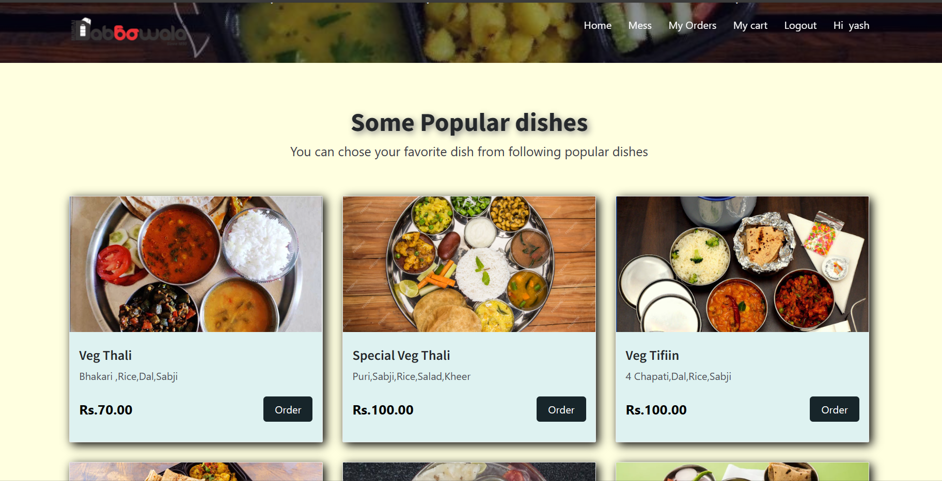

1. Home Page: Upon visiting the website, you will land on the home page.

Here, you can:

- View popular dishes.

- View mess.

- Navigate to different sections using the navigation bar.

2. Dish Listings:

Browse through a variety of dishes.

Each listing provides: -

Dish name,Description and Image.

- Ratings and reviews.

3. Cart Management:

Manage your cart before proceeding to checkout. You can:

- Review items added to your cart.

- Modify quantities or remove items.

- Proceed to checkout for payment.



4. Checkout Process:

Complete your order by following these steps:

1. Enter delivery details.

2. Review order summary.

3. Select payment method.

4. Place your order securely.

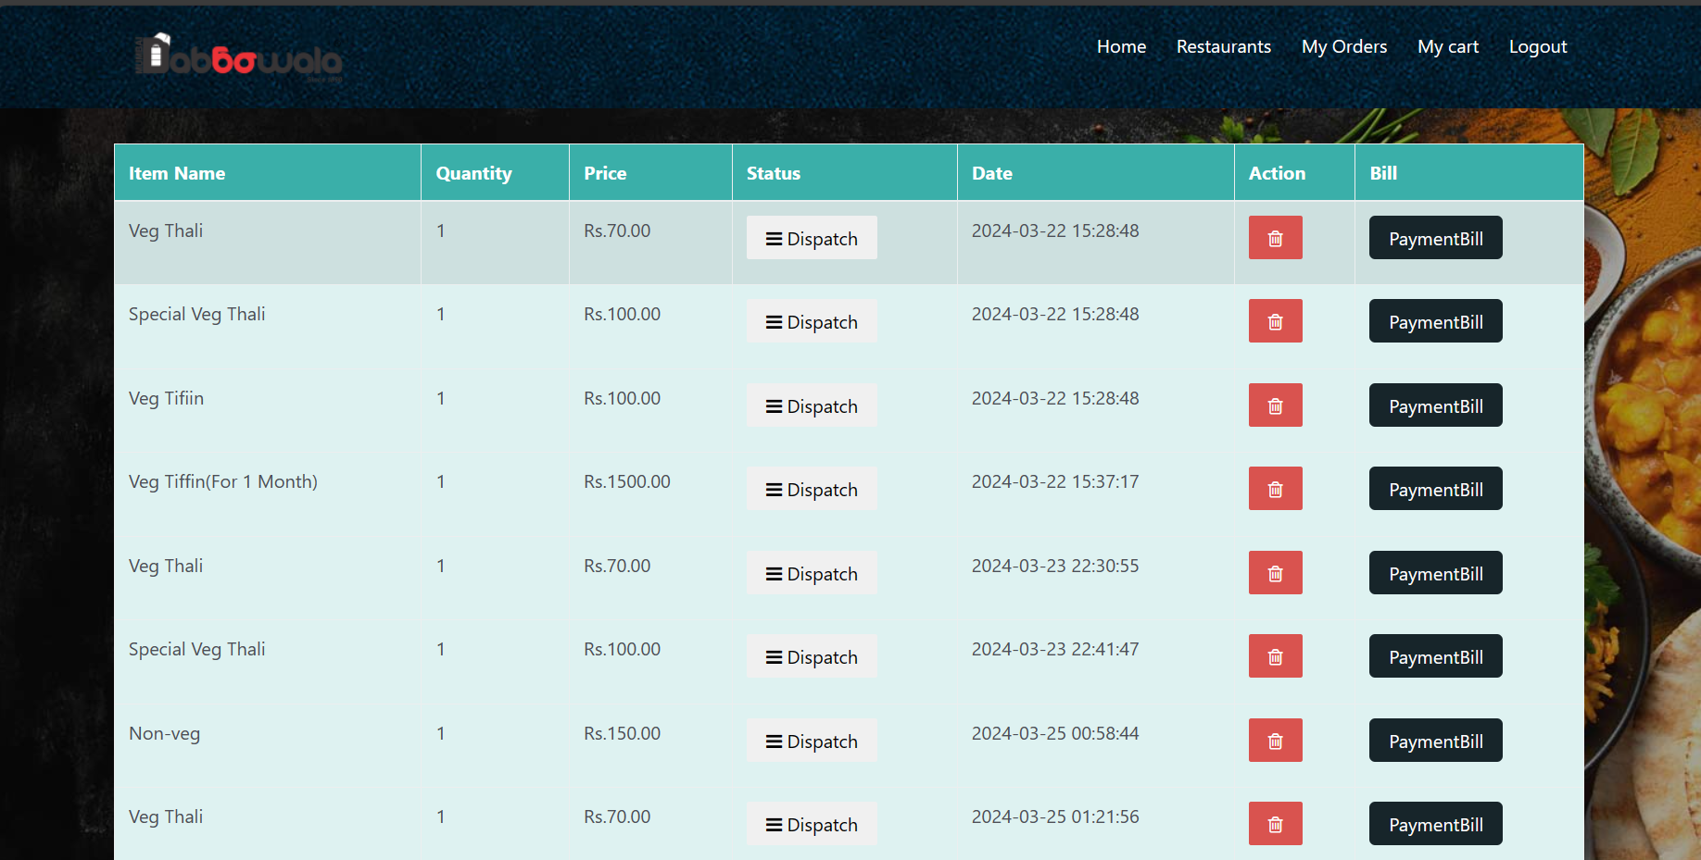

5. status of your order:

- Order confirmation.

- Out for delivery.

**7.1.CONCLUSION**

The development of the OnlineGiftService website marks a significant milestone in Gift service to the evolving needs of modern consumers. Through meticulous planning, robust implementation, and rigorous testing, we have successfully created a platform that revolutionizes the way individuals interact with the industry.

Our platform offers a seamless user experience, allowing customers to explore a diverse range of dishes and categories, place orders effortlessly, and track their deliveries with ease. With features such as user-friendly menu navigation, advanced search capabilities, and secure payment integration, we have prioritized convenience and accessibility for our users.

Moreover, our commitment to quality extends beyond the user interface, encompassing aspects such as category management, order processing, and customer support. By empowering mess owners with intuitive tools for menu creation and management, we enable them to showcase their offerings effectively and reach a broader audience.

The implementation of robust security measures and adherence to industry standards ensure the confidentiality and integrity of user data, fostering trust and confidence among our customers. Additionally, our dedication to continuous improvement drives us to listen attentively to user feedback, address any issues promptly, and innovate proactively to meet emerging needs and trends.

In conclusion, our OnlineGiftService website represents more than just a digital platform it embodies our commitment to excellence, innovation, and customer satisfaction. As we embark on this journey, we remain steadfast in our pursuit of delivering exceptional value to both consumers and service providers, shaping the future of the Gift indusrty landscape.

**7.2.SIGNIFICANCE OF THE SYSTEM**

1. Convenience: Electronic-Gift Shops offer unparalleled convenience, allowing customers to order delicious and nutritious meals with just a few clicks.

2. Time-saving: Busy individuals, students, and professionals can save valuable time by avoiding meal preparation and instead rely on timely Gift deliveries.

3. Health-conscious options: Many Electronic-Gift Shops prioritize health by offering customizable meal plans, catering to various dietary preferences and restrictions.

4. Variety: Customers can enjoy a wide variety of cuisines and dishes from around the world, ensuring they never get bored with their meals.

5. Cost-effective: Electronic-Gift Shops often provide affordable meal options compared to dining out or ordering from Shop, making them an economical choice.

6. Flexible subscriptions: With flexible subscription models, customers can choose daily, weekly, or monthly plans according to their needs and preferences.

7. Reliable delivery: Most Electronic-Gift Shops ensure reliable and timely delivery, giving customers peace of mind about receiving their meals on time.

8. Community support: Supporting local Gift services fosters community engagement and helps small businesses thrive in the competitive Gift industry.

9. Environmental impact: By reducing the need for individual cooking and packaging, Electronic-Gift Shops contribute to reducing Gift waste and carbon emissions.

10. Customization options: Customers can customize their meal preferences, portion sizes, and delivery schedules, ensuring a personalized dining experience.

11. Work-life balance: Electronic-Gift Shops promote a healthier work-life balance by eliminating the need for meal planning and preparation, allowing individuals to focus on other priorities.

**7.3.LIMITATIONS OF THE SYSTEM**

Limitations of the year for Electronic-Gift Shops:

1. Delivery logistics: Despite advancements, ensuring timely and efficient delivery remains a challenge, especially during peak hours or adverse weather conditions.

2. Limited service areas: Electronic-Gift Shops may have constraints on their delivery radius, leaving some potential customers outside their coverage area.

3. Dependency on internet connectivity: Reliance on stable internet connections may hinder accessibility for individuals in areas with poor connectivity or during network outages.

4. Seasonal availability: Certain ingredients or cuisines may not be available year-round, affecting menu options and variety for Electronic-Gift Shops.

5. Gift quality during transit: Maintaining Gift quality and freshness during transportation can be difficult, leading to potential compromises in taste and texture.

**7.4. FUTURE SCOPE OF THE PROJECT**

1. Expansion into new geographical areas:

The project can explore opportunities to expand its service coverage to reach a wider audience and tap into new markets.

2. Diversification of cuisine offerings:

Introducing a broader range of cuisines and specialty dishes can cater to diverse tastes and preferences, attracting a larger customer base.

3. Integration of AI and machine learning:

Implementing AI-driven solutions for personalized recommendations, menu optimization, and predictive ordering can enhance user experience and operational efficiency.

4. Sustainable practices:

Embracing eco-friendly packaging, sourcing locally grown ingredients, and reducing Gift waste can align with growing consumer preferences for sustainable practices.

5. Collaboration with local vendors:

Partnering with local farmers, producers, and suppliers can strengthen community ties and support small businesses while ensuring fresh and high-quality ingredients.

6. Mobile app development:

Investing in a dedicated mobile app can enhance accessibility and convenience for customers, enabling seamless ordering, tracking, and feedback mechanisms.

7. Subscription-based models:

Offering subscription-based meal plans with flexible options for frequency and customization can foster customer loyalty and provide a recurring revenue stream.

8. Virtual kitchen concept:

Exploring the concept of virtual kitchens or cloud kitchens can optimize resource utilization and enable rapid scalability without the need for physical dining spaces.

9. Corporate catering services:

Targeting corporate clients with tailored catering packages for meetings, events, and employee meals can open up lucrative B2B opportunities for the project.

10. Voice-enabled ordering:

Introducing voice-activated ordering capabilities through virtual assistants like Alexa or Google Assistant can streamline the ordering process and enhance accessibility for users.

11. Enhanced user interface:

Continuously improving the website and user interface with intuitive navigation, interactive features, and visually appealing design can elevate the overall user experience.

12. Community engagement initiatives:

Organizing Gift festivals, cooking workshops, and culinary events can foster community engagement, brand awareness, and customer loyalty.

13. Data analytics for insights:

Leveraging data analytics tools to analyze customer behavior, preferences, and trends can drive informed decision-making and targeted marketing strategies.

14. Expansion into related services:

Diversifying into related services such as meal kit delivery, grocery delivery, or catering for special occasions can capitalize on synergies and expand revenue streams.

15. Health and wellness focus:

Introducing healthier menu options, nutritional information, and wellness programs can cater to health-conscious consumers and differentiate the project in the market.

16. Gamification elements:

Incorporating gamification elements like loyalty rewards, challenges, and interactive quizzes can enhance user engagement and retention.

**REFERENCES**

**• W3Schools. Retrieved from https:**

**//www.w3schools.com/**

**• Google. Retrieved from:**

[**www.google.com**](http://www.google.com)

**• PHP tool. Retrieved from:**

[**http://php.net/**](http://php.net/)

**• Bootstrap. Retrieved from:**

[**https://getbootstrap.com/docs/5.3/getting-started/introduction/**](https://getbootstrap.com/docs/5.3/getting-started/introduction/)

**• Geeks for Geeks. Retrieved from:**

[**https://www.geeksforgeeks.org/**](https://www.geeksforgeeks.org/)

**• PHP Reference book:**

**Head First PHP & MySQL(Author- Lynn Beighley** **)**

**The Joy of PHP (Author-Alan Forbes)**

**• Youtube.:**

[**https://www.youtube.com/**](https://www.youtube.com/)

**Note:**

This list is not exhaustive and only includes some of the resources that I found useful during the development of the project.